UNITED STATES
SECURITIES AND EXCHANGE COMMISSION
WASHINGTON, D.C. 20549
FORM 8-K
CURRENT REPORT
Pursuant to Section 13 or 15(d) of the Securities Exchange Act of 1934
Date of Report (Date of earliest event reported): August 5, 2026
FRESHPET, INC.
(Exact name of Registrant as Specified in Its Charter)
Delaware |  |  | 001-36729 |  |  | 20-1884894
(State or Other Jurisdiction  of Incorporation) |  |  | (Commission File Number) |  |  | (IRS Employer  Identification No.)
1450 US-206,  Bedminster, New Jersey |  |  |  |  |  | 07921
(Address of Principal Executive Offices) |  |  |  |  |  | (Zip Code)
Registrant’s Telephone Number, Including Area Code: (201) 520-4000
Not Applicable
(Former Name or Former Address, if Changed Since Last Report)
Check the appropriate box below if the Form 8-K filing is intended to simultaneously satisfy the filing obligation of the registrant under any of the following provisions:
☐ |  |  | Written communications pursuant to Rule 425 under the Securities Act (17 CFR 230.425)
☐ |  |  | Soliciting material pursuant to Rule 14a-12 under the Exchange Act (17 CFR 240.14a-12)
☐ |  |  | Pre-commencement communications pursuant to Rule 14d-2(b) under the Exchange Act (17 CFR 240.14d-2(b))
☐ |  |  | Pre-commencement communications pursuant to Rule 13e-4(c) under the Exchange Act (17 CFR 240.13e-4(c))
Securities registered pursuant to Section 12(b) of the Act:
Title of each class |  |  | Trading Symbol(s) |  |  | Name of each exchange on which registered
Common Stock |  |  | FRPT |  |  | NASDAQ Global Market
Indicate by check mark whether the registrant is an emerging growth company as defined in Rule 405 of the Securities Act of 1933 (§ 230.405 of this chapter) or Rule 12b-2 of the Securities Exchange Act of 1934 (§ 240.12b-2 of this chapter).
Emerging growth company ☐
If an emerging growth company, indicate by check mark if the registrant has elected not to use the extended transition period for complying with any new or revised financial accounting standards provided pursuant to Section 13(a) of the Exchange Act. ☐

Item 2.02. Results of Operations and Financial Condition.
On August 5, 2026, Freshpet, Inc. (“Freshpet”) issued a press release disclosing its financial results for the quarter ended June 30, 2026. The full text of the press release is attached hereto as Exhibit 99.1 and is incorporated herein by reference.
As previously announced, Freshpet will hold a conference call at 8:00 a.m., Eastern Time, on Wednesday, August 5, 2026, to discuss its financial results for the quarter ended June 30, 2026.
Freshpet references non-GAAP financial information in the press release and makes similar references in the transcript to the conference call. A reconciliation of these non-GAAP financial measures to the nearest comparable GAAP financial measures is contained in the attached Exhibit 99.1 press release.

Item 7.01. Regulation FD Disclosure.
On August 5, 2026, Freshpet published to the investor relations section of its website a presentation which will be used by Freshpet’s management team in meetings with analysts and stockholders. A copy of the presentation is attached hereto as Exhibit 99.2 and is incorporated herein by reference.
The information furnished with Item 2.02 and this Item 7.01, including Exhibits 99.1 and 99.2, shall not be deemed “filed” for purposes of Section 18 of the Securities Exchange Act of 1934, as amended (“the Exchange Act”) or incorporated by reference into any other filing under the Securities Act of 1933, as amended, or the Exchange Act, except as expressly set forth by specific reference in such a filing.
Freshpet uses the “Investors” section of its website (investors.freshpet.com) as a means of disclosing material non-public information and for complying with its disclosure obligations under Regulation FD.

Item 9.01. Financial Statements and Exhibits.
(d) Exhibits
Exhibit  Number |  |  |  |  |  | Description
99.1 |  |  |  |  |  | Press Release, dated August 5, 2026
99.2 |  |  |  |  |  | Investors Presentation
104 |  |  |  |  |  | Cover Page Interactive Data File (embedded within the Inline XBRL document).

SIGNATURE
Pursuant to the requirements of the Securities Exchange Act of 1934, the registrant has duly caused this report to be signed on its behalf by the undersigned hereunto duly authorized.
 |  |  | FRESHPET, INC.
Date: August 5, 2026 |  |  | By: |  |  | /s/ John G. O'Connor
 |  |  | Name: John G. O'Connor
 |  |  | Title: Chief Financial Officer

Exhibit 99.1

Freshpet, Inc. Reports Second Quarter 2026 Financial Results

Delivers ~15% Net Sales Growth
Raises 2026 Net Sales and Adjusted EBITDA Outlook
Updates Long-Term Adjusted Gross Margin Target to >49%
Bedminster, N.J. – August 5, 2026 – Freshpet, Inc. (“Freshpet” or the “Company”) (Nasdaq: FRPT) today reported financial results for its second quarter and six months ended June 30, 2026.
Second Quarter 2026 Financial Highlights Compared to Prior Year Period
•Net sales of $305.6 million, an increase of 15.5%.
•Gross margin of 42.1%, compared to the prior year period of 40.9%.
•Adjusted Gross Margin of 48.6%, compared to the prior year period of 46.9%.1
•Net income of $19.5 million, compared to the prior year period net income of $16.4 million.
•Adjusted EBITDA of $52.2 million, compared to the prior year period of $44.4 million.1
"Our second quarter performance demonstrates the strength and resilience of our business model. It also reinforces our belief that fresh is the future of pet food and that Freshpet is uniquely positioned to win in that segment," commented Billy Cyr, Freshpet’s Chief Executive Officer. "Despite economic headwinds and new competitors, we grew significantly faster than the category, improved margins, and produced strong cash flow. We believe our manufacturing scale and expertise enables us to deliver the highest quality products at the lowest costs, while our expanding omnichannel presence enables us to grow market share and deepen engagement with our most valuable pet parents. This gives us confidence in our ability to fulfill Freshpet's mission to help dogs and cats live longer, happier lives with the people who love them and create long-term value for shareholders."
Second Quarter 2026
Net sales increased 15.5% to $305.6 million for the second quarter of 2026, compared to $264.7 million in the prior year period. The increase in net sales was primarily driven by volume gains of 15.7%, partially offset by unfavorable price/mix of 0.2%.
Gross profit was $128.7 million, or 42.1% as a percentage of net sales, for the second quarter of 2026, compared to $108.2 million, or 40.9% as a percentage of net sales, in the prior year period. Gross profit as a percentage of net sales increased primarily due to lower input costs and improved leverage on plant expenses, partially offset by higher quality costs related to the startup of new technology lines. For the second quarter of 2026, Adjusted Gross Profit was $148.4 million, or 48.6% as a percentage of net sales, compared to $124.0 million, or 46.9% as a percentage of net sales, in the prior year period.1
Selling, general and administrative expenses (“SG&A”) were $107.0 million, or 35.0% as a percentage of net sales, for the second quarter of 2026, compared to $90.4 million, or 34.1% as a percentage of net sales, in the prior year period. SG&A as a percentage of net sales increased primarily due to increased logistics costs and variable compensation accrual, partially offset by decreased media spend as a percentage of net sales. Adjusted SG&A for the second quarter of 2026 was $96.1 million, or 31.4% as a percentage of net sales, compared to $79.6 million, or 30.1% as a percentage of net sales, in the prior year period.1
Net income was $19.5 million for the second quarter of 2026 compared to $16.4 million in the prior year period. The increase in net income was due to an additional gain on equity investment, as a result of certain post-closing adjustments on the sale of 100% of our non-controlling interest in a privately held company following its acquisition by a third party, and contributions from higher sales, partially offset by the increases in SG&A and income tax expense.
1 Adjusted Gross Margin, Adjusted Gross Profit, Adjusted SG&A, Adjusted EBITDA and Free Cash Flow are non-GAAP financial measures. See "Non-GAAP Measures" for how the Company defines these measures and the financial tables that accompany this release for reconciliations of these measures to the closest comparable GAAP measures.
1
Adjusted EBITDA was $52.2 million for the second quarter of 2026 compared to $44.4 million in the prior year period.1 The increase in Adjusted EBITDA was a result of increased Adjusted Gross Profit, partially offset by higher Adjusted SG&A.
First Six Months of 2026
Net sales increased 14.3% to $603.2 million for the first six months of 2026, compared to $527.9 million in the prior year period. The increase in net sales was primarily driven by volume gains of 15.1%, partially offset by unfavorable price/mix of 0.8%.
Gross profit was $249.4 million, or 41.3% as a percentage of net sales, for the first six months of 2026, compared to $212.0 million, or 40.2% as a percentage of net sales, in the prior year period. Gross profit as a percentage of net sales increased primarily due to lower input costs and improved leverage on plant expenses, partially offset by higher quality costs related to the startup of new technology lines. For the first six months of 2026, Adjusted Gross Profit was $288.0 million, or 47.7% as a percentage of net sales, compared to $244.3 million, or 46.3% as a percentage of net sales, in the prior year period.1
SG&A were $223.3 million, or 37.0% as a percentage of net sales, for the first six months of 2026, compared to $205.7 million, or 39.0% as a percentage of net sales, in the prior year period. SG&A as a percentage of net sales decreased primarily due to a decrease in non-recurring charges that occurred in the first half of 2025, partially offset by increased logistics costs and variable compensation accrual. Adjusted SG&A for the first six months of 2026 was $197.8 million, or 32.8% as a percentage of net sales, compared to $164.3 million, or 31.1% as a percentage of net sales, in the prior year period.1
Net income was $68.0 million for the first six months of 2026 compared to $3.7 million in the prior year period. The increase in net income was due to the gain on equity investment as a result of the sale of 100% of our non-controlling interest in a privately held company following its acquisition by a third party, contributions from higher sales, and decreased non-recurring SG&A charges, partially offset by increases in logistics costs, variable compensation accrual and income tax expense.
Adjusted EBITDA was $90.1 million for the first six months of 2026 compared to $79.9 million in the prior year period.1 The increase in Adjusted EBITDA was a result of increased Adjusted Gross Profit, partially offset by higher Adjusted SG&A.
Balance Sheet
As of June 30, 2026, the Company had cash and cash equivalents of $350.8 million with $398.4 million of debt outstanding, net of $4.1 million of unamortized debt issuance costs. Cash and cash equivalents increased $72.8 million compared to $278.0 million as of December 31, 2025, primarily as a result of the $100.0 million of cash proceeds received from the sale of our equity investment and $27.4 million of Free Cash Flow, partially offset by $54.4 million of share repurchases pursuant to the previously announced share repurchase program. For the six months ended June 30, 2026, cash from operations was $84.8 million, an increase of $46.1 million compared to the prior year period.
Outlook
For full year 2026, the Company is updating its guidance and now expects the following:
•Net sales growth in the range of 10% to 12%, compared to growth of 8% to 11% in the previous guidance;
•Adjusted EBITDA in the range of $210 million to $220 million, compared to $205 million to $215 million in the previous guidance; and
•Positive Free Cash Flow with capital expenditures of ~$150 million, unchanged from the previous guidance.
The Company is also updating its long-term guidance. For full year 2027, the Company now expects:
•Net sales well in excess of the category growth rate, unchanged;
•Adjusted Gross Margin of at least 49%, compared to at least 48% previously; and
•Adjusted EBITDA margin in the range of 20% to 22%, unchanged.
2
The Company does not provide guidance for net income, the U.S. GAAP measure most directly comparable to Adjusted EBITDA, and similarly cannot provide a reconciliation between its forecasted Adjusted EBITDA and net income metrics without unreasonable effort due to the unavailability of reliable estimates for certain components of net income and the respective reconciliations, including the timing of and amount of costs of goods sold and selling, general and administrative expenses. These items are not within the Company's control and may vary greatly between periods and could significantly impact future results.
Conference Call & Earnings Presentation Webcast Information
As previously announced, today, August 5, 2026, the Company will host a conference call beginning at 8:00 a.m. Eastern Time with members of its leadership team. The conference call webcast will be available live over the Internet through the "Investors" section of the Company's website at www.freshpet.com. To participate on the live call, listeners in North America may dial (844) 825-9789 and international listeners may dial (412) 317-5180; the passcode is 10210593.
About Freshpet
Freshpet's mission is to help dogs and cats live longer, happier, healthier lives with the people who love them. Developed by on-staff Veterinary Nutritionists, Veterinarians and Food Scientists, recipes are made from whole ingredients, like fresh meats, vegetables and fruits, and are cooked in small batches at lower temperatures to preserve their natural goodness and made at our Freshpet Kitchens. Freshpet foods and treats are kept refrigerated until they arrive at Freshpet Fridges in local markets or delivered directly to consumers.
Freshpet is available in select grocery, mass, digital, pet specialty, and club retailers across the United States, Canada and Europe, as well as online in the U.S. From the care they take to source their ingredients and make their food, to the moment it reaches your home, Freshpet's commitment to integrity, transparency and social responsibility is a point of pride.
Forward Looking Statements
Certain statements in this press release constitute “forward-looking” statements within the meaning of the Private Securities Litigation Reform Act of 1995 and are based on our current expectations and assumptions. These include statements regarding our belief in the impact of our manufacturing expertise and omnichannel strategy, 2026 guidance and 2027 financial targets, and being uniquely positioned to capture a meaningful share of the category. Such statements are subject to risks and uncertainties that could cause actual results to differ materially from those discussed in the forward-looking statements including, but not limited to, those identified in connection with such statements, the implementation of our new technologies in the time frame, at the rate, at the cost, or with anticipated efficiencies and impact on product quality we expect, economic uncertainty, changes in rates of pet acquisition, the launch of competitive products at higher quality or less cost, impact of tariffs, fuel, energy and ingredient pricing, effectiveness of media campaigns, success rate of new chillers, organizational changes, and most prominently, the risks discussed under the heading "Risk Factors" in the Company's latest annual report on Form 10-K and in quarterly reports on Form 10-Q filed with the Securities and Exchange Commission. Such forward-looking statements are made only as of the date of this release. Freshpet undertakes no obligation to publicly update or revise any forward-looking statement because of new information, future events or otherwise, except as otherwise required by law. If we do update one or more forward-looking statements, no inference should be made that we will make additional updates with respect to those or other forward-looking statements.
Non-GAAP Financial Measures
Freshpet uses the following non-GAAP financial measures in its financial communications. These non-GAAP financial measures should be considered as supplements to the U.S. GAAP reported measures, should not be considered replacements for, or superior to, the U.S. GAAP measures and may not be comparable to similarly named measures used by other companies. Such financial measures are not financial measures prepared in accordance with U.S. GAAP.
•Adjusted Gross Profit
•Adjusted Gross Profit as a percentage of net sales (Adjusted Gross Margin)
•Adjusted SG&A Expenses
•Adjusted SG&A Expenses as a percentage of net sales
•EBITDA
•Adjusted EBITDA
3
•Adjusted EBITDA as a percentage of net sales (Adjusted EBITDA Margin)
•Free Cash Flow
Adjusted Gross Profit: Freshpet defines Adjusted Gross Profit as gross profit before depreciation expense, non-cash share-based compensation and loss on disposal of manufacturing equipment.
Adjusted SG&A Expenses: Freshpet defines Adjusted SG&A as SG&A expenses before depreciation and amortization expense, non-cash share-based compensation, loss on disposal of equipment, distributor transition costs, legal obligation and international business charges.
EBITDA and Adjusted EBITDA: EBITDA represents net income (loss) plus depreciation and amortization expense, interest expense net of interest income and income tax expense, and Adjusted EBITDA represents EBITDA less gain on equity investment, plus non-cash share-based compensation expense, loss on disposal of property, plant and equipment, distributor transition costs, legal obligation, and international business charges.
Free Cash Flow: Freshpet defines Free Cash Flow as net cash flows provided by operating activities less capital expenditures.
Management believes that the non-GAAP financial measures are meaningful to investors because they provide a view of the Company with respect to ongoing operating results. The non-GAAP financial measures are shown as supplemental disclosures in this release because they are widely used by the investment community for analysis and comparative evaluation. They also provide additional metrics to evaluate the Company’s operations and, when considered with both the Company’s GAAP results and the reconciliation to their most directly comparable U.S. GAAP measures, provide a more complete understanding of the Company’s business than could be obtained absent this disclosure. The non-GAAP measures are not and should not be considered an alternative to the most directly comparable U.S. GAAP measures or any other figure calculated in accordance with U.S. GAAP, or as an indicator of operating performance. The Company’s calculation of the non-GAAP financial measures may differ from methods used by other companies. Management believes that the non-GAAP measures are important to an understanding of the Company's overall operating results in the periods presented. The non-GAAP financial measures are not recognized in accordance with U.S. GAAP and should not be viewed as an alternative to U.S. GAAP measures of performance.
Investor Contact:
Rachel Ulsh
Rulsh@freshpet.com
Media Contact:
Press@freshpet.com

4
FRESHPET, INC. AND SUBSIDIARIES
CONDENSED CONSOLIDATED BALANCE SHEETS
(Unaudited, in thousands, except per share data)
 |  |  | June 30,  2026 |  |  |  |  |  | December 31,  2025
ASSETS
CURRENT ASSETS:
Cash and cash equivalents |  |  | $ | 350,809 |  |  |  |  | $ | 277,975
Accounts receivable, net of allowance for doubtful accounts |  |  | 65,383 |  |  |  |  |  | 63,762
Inventories, net |  |  | 86,734 |  |  |  |  |  | 76,766
Prepaid expenses |  |  | 7,744 |  |  |  |  |  | 9,807
Other current assets |  |  | 6,396 |  |  |  |  |  | 7,404
Total Current Assets |  |  | 517,066 |  |  |  |  |  | 435,714
Property, plant and equipment, net |  |  | 1,146,325 |  |  |  |  |  | 1,138,671
Operating lease right of use assets |  |  | 64,786 |  |  |  |  |  | 66,424
Long term investment in equity securities |  |  | — |  |  |  |  |  | 33,446
Deferred tax assets, net |  |  | 47,405 |  |  |  |  |  | 68,893
Other assets |  |  | 36,833 |  |  |  |  |  | 34,627
Total Assets |  |  | $ | 1,812,415 |  |  |  |  | $ | 1,777,775
LIABILITIES AND STOCKHOLDERS' EQUITY
CURRENT LIABILITIES:
Accounts payable |  |  | $ | 36,817 |  |  |  |  | $ | 42,429
Accrued expenses |  |  | 44,116 |  |  |  |  |  | 31,610
Current operating lease liabilities |  |  | 2,189 |  |  |  |  |  | 2,241
Current finance lease liabilities |  |  | 2,397 |  |  |  |  |  | 2,315
Total Current Liabilities |  |  | 85,519 |  |  |  |  |  | 78,595
Convertible senior notes |  |  | 398,443 |  |  |  |  |  | 397,330
Long term operating lease liabilities |  |  | 64,046 |  |  |  |  |  | 65,023
Long term finance lease liabilities |  |  | 26,582 |  |  |  |  |  | 28,075
Deferred tax liabilities, net |  |  | 129 |  |  |  |  |  | 93
Total Liabilities |  |  | $ | 574,719 |  |  |  |  | $ | 569,116
Commitments and contingencies |  |  | — |  |  |  |  |  | —
STOCKHOLDERS' EQUITY:
Common stock — voting, $0.001 par value, 200,000 shares authorized, 49,671 issued and 48,625 outstanding on June 30, 2026, and 48,985 issued and 48,970 outstanding on December 31, 2025 |  |  | 49 |  |  |  |  |  | 49
Additional paid-in capital |  |  | 1,367,847 |  |  |  |  |  | 1,351,201
Accumulated deficit |  |  | (74,673) |  |  |  |  |  | (142,669)
Accumulated other comprehensive (loss) income |  |  | (706) |  |  |  |  |  | 334
Treasury stock, at cost, inclusive of excise tax and broker fees — 1,046 shares on June 30, 2026 and 14 shares on December 31, 2025 |  |  | (54,821) |  |  |  |  |  | (256)
Total Stockholders' Equity |  |  | 1,237,696 |  |  |  |  |  | 1,208,659
Total Liabilities and Stockholders' Equity |  |  | $ | 1,812,415 |  |  |  |  | $ | 1,777,775

5
FRESHPET, INC. AND SUBSIDIARIES
CONDENSED CONSOLIDATED STATEMENTS OF INCOME AND COMPREHENSIVE INCOME
(Unaudited, in thousands, except per share data)
 |  |  | For the Three Months Ended  June 30, |  |  |  |  |  |  |  |  |  |  |  | For the Six Months Ended  June 30,
 |  |  | 2026 |  |  |  |  |  | 2025 |  |  |  |  |  | 2026 |  |  |  |  |  | 2025
NET SALES |  |  | $ | 305,587 |  |  |  |  | $ | 264,689 |  |  |  |  | $ | 603,231 |  |  |  |  | $ | 527,938
COST OF GOODS SOLD |  |  | 176,893 |  |  |  |  |  | 156,499 |  |  |  |  |  | 353,863 |  |  |  |  |  | 315,960
GROSS PROFIT |  |  | 128,694 |  |  |  |  |  | 108,190 |  |  |  |  |  | 249,368 |  |  |  |  |  | 211,978
SELLING, GENERAL, AND ADMINISTRATIVE EXPENSES |  |  | 106,985 |  |  |  |  |  | 90,386 |  |  |  |  |  | 223,328 |  |  |  |  |  | 205,671
INCOME FROM OPERATIONS |  |  | 21,709 |  |  |  |  |  | 17,804 |  |  |  |  |  | 26,040 |  |  |  |  |  | 6,307
OTHER INCOME (EXPENSES):
Interest and Other Income, net |  |  | 2,830 |  |  |  |  |  | 2,199 |  |  |  |  |  | 5,713 |  |  |  |  |  | 4,592
Interest Expense |  |  | (3,483) |  |  |  |  |  | (3,749) |  |  |  |  |  | (7,069) |  |  |  |  |  | (7,208)
Gain on Equity Investment |  |  | 4,539 |  |  |  |  |  | — |  |  |  |  |  | 66,552 |  |  |  |  |  | —
TOTAL OTHER INCOME (EXPENSE) |  |  | 3,886 |  |  |  |  |  | (1,550) |  |  |  |  |  | 65,196 |  |  |  |  |  | (2,616)
INCOME BEFORE INCOME TAXES |  |  | 25,595 |  |  |  |  |  | 16,254 |  |  |  |  |  | 91,236 |  |  |  |  |  | 3,691
INCOME TAX EXPENSE (BENEFIT) |  |  | 6,107 |  |  |  |  |  | (102) |  |  |  |  |  | 23,240 |  |  |  |  |  | 32
INCOME ATTRIBUTABLE TO COMMON STOCKHOLDERS |  |  | $ | 19,488 |  |  |  |  | $ | 16,356 |  |  |  |  | $ | 67,996 |  |  |  |  | $ | 3,659
OTHER COMPREHENSIVE (LOSS) INCOME:
Change in foreign currency translation |  |  | $ | (247) |  |  |  |  | $ | 240 |  |  |  |  | $ | (1,040) |  |  |  |  | $ | 451
TOTAL OTHER COMPREHENSIVE (LOSS) INCOME |  |  | (247) |  |  |  |  |  | 240 |  |  |  |  |  | (1,040) |  |  |  |  |  | 451
TOTAL COMPREHENSIVE INCOME |  |  | $ | 19,241 |  |  |  |  | $ | 16,596 |  |  |  |  | $ | 66,956 |  |  |  |  | $ | 4,110
NET INCOME PER SHARE ATTRIBUTABLE TO COMMON STOCKHOLDERS
-BASIC |  |  | $ | 0.40 |  |  |  |  | $ | 0.34 |  |  |  |  | $ | 1.38 |  |  |  |  | $ | 0.08
-DILUTED |  |  | $ | 0.39 |  |  |  |  | $ | 0.33 |  |  |  |  | $ | 1.29 |  |  |  |  | $ | 0.07
WEIGHTED AVERAGE SHARES OF COMMON STOCK OUTSTANDING
-BASIC |  |  | 49,197 |  |  |  |  |  | 48,778 |  |  |  |  |  | 49,129 |  |  |  |  |  | 48,755
-DILUTED |  |  | 55,811 |  |  |  |  |  | 50,198 |  |  |  |  |  | 55,926 |  |  |  |  |  | 50,256

6
FRESHPET, INC. AND SUBSIDIARIES
CONDENSED CONSOLIDATED STATEMENTS OF CASH FLOWS
(Unaudited, in thousands)
For the Six Months Ended
June 30,
 |  |  | 2026 |  |  |  |  |  | 2025
CASH FLOWS FROM OPERATING ACTIVITIES:
Net income |  |  | $ | 67,996 |  |  |  |  | $ | 3,659
Adjustments to reconcile net income to net cash flows provided by operating activities:
Provision for loss on accounts receivable |  |  | 14 |  |  |  |  |  | 11,452
Loss on disposal of property, plant and equipment |  |  | 154 |  |  |  |  |  | 1,229
Share-based compensation |  |  | 15,516 |  |  |  |  |  | 15,037
Depreciation and amortization |  |  | 49,954 |  |  |  |  |  | 42,436
Amortization of deferred financing costs |  |  | 1,113 |  |  |  |  |  | 1,074
Change in operating lease right of use asset |  |  | 1,638 |  |  |  |  |  | 727
Deferred income taxes |  |  | 21,528 |  |  |  |  |  | —
Gain on equity investment |  |  | (66,552) |  |  |  |  |  | —
Changes in operating assets and liabilities:
Accounts receivable |  |  | (1,467) |  |  |  |  |  | (3,208)
Inventories |  |  | (9,991) |  |  |  |  |  | (9,400)
Prepaid expenses and other current assets |  |  | 2,445 |  |  |  |  |  | (3,913)
Other assets |  |  | (3,725) |  |  |  |  |  | (3,060)
Accounts payable |  |  | (5,554) |  |  |  |  |  | 2,291
Accrued expenses |  |  | 12,713 |  |  |  |  |  | (18,958)
Operating lease liability |  |  | (1,028) |  |  |  |  |  | (673)
Net cash flows provided by operating activities |  |  | 84,754 |  |  |  |  |  | 38,693
CASH FLOWS FROM INVESTING ACTIVITIES:
Proceeds from sale of equity investment |  |  | 99,998 |  |  |  |  |  | —
Acquisitions of property, plant and equipment, software and deposits on equipment |  |  | (57,324) |  |  |  |  |  | (59,932)
Net cash flows provided by (used in) investing activities |  |  | 42,674 |  |  |  |  |  | (59,932)
CASH FLOWS FROM FINANCING ACTIVITIES:
Purchase of treasury stock, inclusive of broker fees |  |  | (54,391) |  |  |  |  |  | —
Proceeds from exercise of options to purchase common stock |  |  | 5,985 |  |  |  |  |  | 187
Tax withholdings related to net shares settlements of restricted stock units |  |  | (4,632) |  |  |  |  |  | (2,860)
Principal payments under finance lease obligations |  |  | (1,556) |  |  |  |  |  | (1,037)
Net cash flows used in financing activities |  |  | (54,594) |  |  |  |  |  | (3,710)
NET CHANGE IN CASH AND CASH EQUIVALENTS |  |  | 72,834 |  |  |  |  |  | (24,949)
CASH AND CASH EQUIVALENTS, BEGINNING OF YEAR |  |  | 277,975 |  |  |  |  |  | 268,633
CASH AND CASH EQUIVALENTS, END OF PERIOD |  |  | $ | 350,809 |  |  |  |  | $ | 243,684

7
FRESHPET, INC. AND SUBSIDIARIES
RECONCILIATION BETWEEN GROSS PROFIT AND ADJUSTED GROSS PROFIT
 |  |  | Three Months Ended  June 30, |  |  |  |  |  |  |  |  |  |  |  | Six Months Ended  June 30,
 |  |  | 2026 |  |  |  |  |  | 2025 |  |  |  |  |  | 2026 |  |  |  |  |  | 2025
 |  |  | (Dollars in thousands)
Gross profit |  |  | $ | 128,694 |  |  |  |  | $ | 108,190 |  |  |  |  | $ | 249,368 |  |  |  |  | $ | 211,978
Depreciation expense |  |  | 17,858 |  |  |  |  |  | 13,729 |  |  |  |  |  | 35,156 |  |  |  |  |  | 28,909
Non-cash share-based compensation |  |  | 1,882 |  |  |  |  |  | 1,831 |  |  |  |  |  | 3,469 |  |  |  |  |  | 3,114
Loss on disposal of manufacturing equipment |  |  | — |  |  |  |  |  | 260 |  |  |  |  |  | 12 |  |  |  |  |  | 255
Adjusted Gross Profit |  |  | $ | 148,434 |  |  |  |  | $ | 124,010 |  |  |  |  | $ | 288,005 |  |  |  |  | $ | 244,256
Adjusted Gross Profit as a % of Net Sales |  |  | 48.6 |  | % |  |  |  | 46.9 |  | % |  |  |  | 47.7 |  | % |  |  |  | 46.3 |  | %

8
FRESHPET, INC. AND SUBSIDIARIES
RECONCILIATION BETWEEN SG&A EXPENSES AND ADJUSTED SG&A EXPENSES
 |  |  | Three Months Ended  June 30, |  |  |  |  |  |  |  |  |  |  |  | Six Months Ended  June 30,
 |  |  | 2026 |  |  |  |  |  | 2025 |  |  |  |  |  | 2026 |  |  |  |  |  | 2025
 |  |  | (Dollars in thousands)
SG&A expenses |  |  | $ | 106,985 |  |  |  |  | $ | 90,386 |  |  |  |  | $ | 223,328 |  |  |  |  | $ | 205,671
Depreciation and amortization expense |  |  | 6,394 |  |  |  |  |  | 6,167 |  |  |  |  |  | 13,374 |  |  |  |  |  | 12,104
Non-cash share-based compensation (a) |  |  | 4,498 |  |  |  |  |  | 4,390 |  |  |  |  |  | 12,047 |  |  |  |  |  | 11,923
Loss on disposal of equipment |  |  | 28 |  |  |  |  |  | 225 |  |  |  |  |  | 142 |  |  |  |  |  | 391
Distributor transition costs (b) |  |  | — |  |  |  |  |  | — |  |  |  |  |  | — |  |  |  |  |  | 10,680
Legal obligation (c) |  |  | — |  |  |  |  |  | — |  |  |  |  |  | — |  |  |  |  |  | 4,987
International business charges (d) |  |  | — |  |  |  |  |  | — |  |  |  |  |  | — |  |  |  |  |  | 1,273
Adjusted SG&A Expenses |  |  | $ | 96,065 |  |  |  |  | $ | 79,604 |  |  |  |  | $ | 197,765 |  |  |  |  | $ | 164,313
Adjusted SG&A Expenses as a % of Net Sales |  |  | 31.4 |  | % |  |  |  | 30.1 |  | % |  |  |  | 32.8 |  | % |  |  |  | 31.1 |  | %
(a)Includes true-ups to share-based compensation expense. We have certain outstanding share-based awards with performance-based vesting conditions that require the achievement of certain Adjusted EBITDA margins, Adjusted EBITDA and/or Net Sales targets as a condition of vesting. At each reporting period, we reassess the probability of achieving the performance criteria and the performance period required to meet those targets. When the probability of achieving such performance conditions changes, the compensation cost previously recorded is adjusted as needed. When such performance conditions are deemed to be improbable of achievement, the compensation cost previously recorded is reversed.
(b)Represents a non-recurring loss as a result of an accounts receivable write-off in connection with the liquidation of one of our pet specialty distributors. Concurrent with its liquidation, we transitioned to a new distribution partner, who is a leading pet specialty distributor and who we anticipate will facilitate sales to pet specialty stores. Thus, despite the transitory impact during the first quarter of 2025, our ability to continue to generate sales is consistent with what we would expect to generate within the pet specialty channel.
(c)Represents the net settlement charges for all claims related to the litigation with Phillips.
(d)Represents termination costs due to a business change in our international go-to-market strategy.

9
FRESHPET, INC. AND SUBSIDIARIES
RECONCILIATION BETWEEN NET INCOME AND ADJUSTED EBITDA
 |  |  | Three Months Ended  June 30, |  |  |  |  |  |  |  |  |  |  |  | Six Months Ended  June 30,
 |  |  | 2026 |  |  |  |  |  | 2025 |  |  |  |  |  | 2026 |  |  |  |  |  | 2025
 |  |  | (Dollars in thousands)
Net income |  |  | $ | 19,488 |  |  |  |  | $ | 16,356 |  |  |  |  | $ | 67,996 |  |  |  |  | $ | 3,659
Depreciation and amortization |  |  | 24,252 |  |  |  |  |  | 19,896 |  |  |  |  |  | 48,530 |  |  |  |  |  | 41,013
Interest expense, net of interest income |  |  | 484 |  |  |  |  |  | 1,546 |  |  |  |  |  | 1,189 |  |  |  |  |  | 2,610
Income tax expense |  |  | 6,107 |  |  |  |  |  | (102) |  |  |  |  |  | 23,240 |  |  |  |  |  | 32
EBITDA |  |  | 50,331 |  |  |  |  |  | 37,696 |  |  |  |  |  | 140,955 |  |  |  |  |  | 47,314
Non-cash share-based compensation (a) |  |  | 6,380 |  |  |  |  |  | 6,221 |  |  |  |  |  | 15,516 |  |  |  |  |  | 15,037
Loss on disposal of property, plant and equipment |  |  | 28 |  |  |  |  |  | 485 |  |  |  |  |  | 154 |  |  |  |  |  | 646
Gain on equity investment |  |  | (4,539) |  |  |  |  |  | — |  |  |  |  |  | (66,552) |  |  |  |  |  | —
Distributor transition costs (b) |  |  | — |  |  |  |  |  | — |  |  |  |  |  | — |  |  |  |  |  | 10,680
Legal obligation (c) |  |  | — |  |  |  |  |  | — |  |  |  |  |  | — |  |  |  |  |  | 4,987
International business charges (d) |  |  | — |  |  |  |  |  | — |  |  |  |  |  | — |  |  |  |  |  | 1,273
Adjusted EBITDA |  |  | $ | 52,200 |  |  |  |  | $ | 44,402 |  |  |  |  | $ | 90,073 |  |  |  |  | $ | 79,937
Adjusted EBITDA as a % of Net Sales |  |  | 17.1 |  | % |  |  |  | 16.8 |  | % |  |  |  | 14.9 |  | % |  |  |  | 15.1 |  | %
(a)Includes true-ups to share-based compensation expense. We have certain outstanding share-based awards with performance-based vesting conditions that require the achievement of certain Adjusted EBITDA margins, Adjusted EBITDA and/or Net Sales targets as a condition of vesting. At each reporting period, we reassess the probability of achieving the performance criteria and the performance period required to meet those targets. When the probability of achieving such performance conditions changes, the compensation cost previously recorded is adjusted as needed. When such performance conditions are deemed to be improbable of achievement, the compensation cost previously recorded is reversed.
(b)Represents a non-recurring loss as a result of an accounts receivable write-off in connection with the liquidation of one of our pet specialty distributors. Concurrent with its liquidation, we transitioned to a new distribution partner, who is a leading pet specialty distributor and who we anticipate will facilitate sales to pet specialty stores. Thus, despite the transitory impact during the first quarter of 2025, our ability to continue to generate sales is consistent with what we would expect to generate within the pet specialty channel.
(c)Represents the net settlement charges for all claims related to the litigation with Phillips.
(d)Represents termination costs due to a business change in our international go-to-market strategy.

10
FRESHPET, INC. AND SUBSIDIARIES
RECONCILIATION BETWEEN NET CASH FLOWS PROVIDED BY OPERATING ACTIVITIES AND FREE CASH FLOW
Six Months Ended
June 30,
 |  |  | 2026 |  |  |  |  |  | 2025
 |  |  | (Dollars in thousands)
Net cash flows provided by operating activities |  |  | $ | 84,754 |  |  |  |  | $ | 38,693
less: capital expenditures2 |  |  | (57,324) |  |  |  |  |  | (59,932)
Free Cash Flow |  |  | $ | 27,430 |  |  |  |  | $ | (21,239)
2 Capital expenditures is equivalent to the amount included in "Acquisitions of property, plant and equipment, software and deposits on equipment" on our Consolidated Statements of Cash Flows for the reported period.

11
1 August 5, 2026 Q2 2026 Earnings

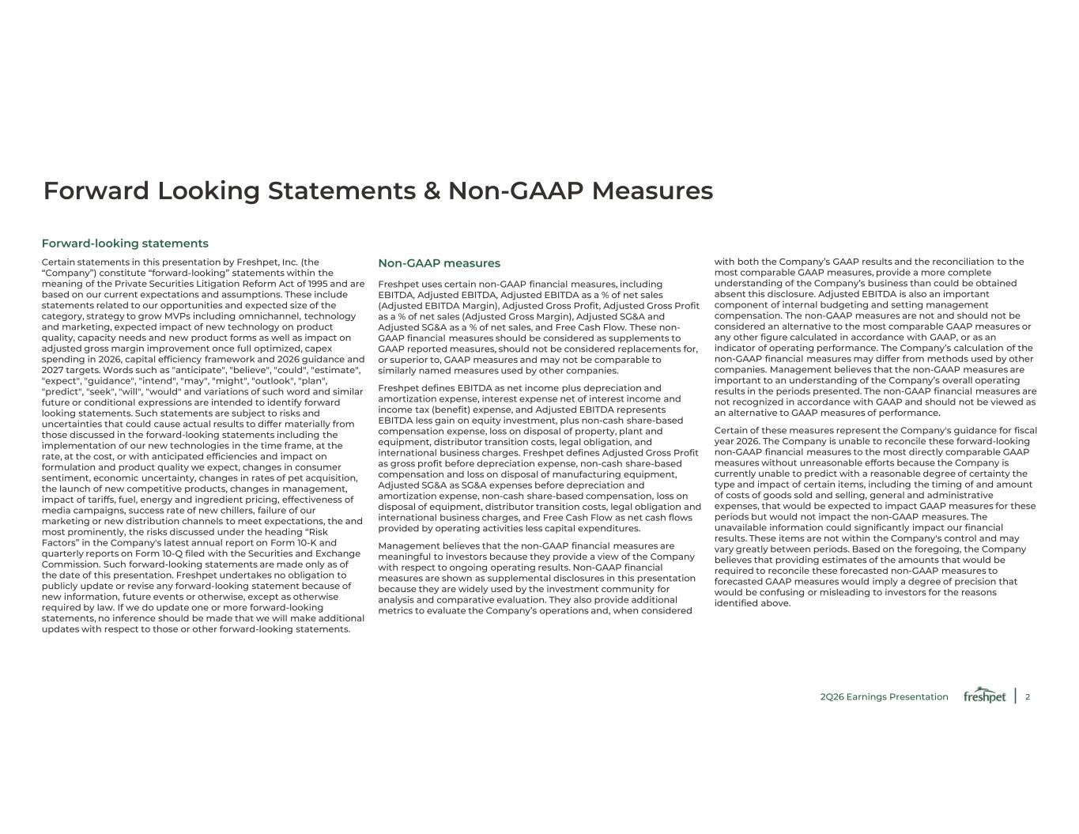
2 Forward Looking Statements & Non-GAAP Measures Forward-looking statements Certain statements in this presentation by Freshpet, Inc. (the “Company”) constitute “forward-looking” statements within the meaning of the Private Securities Litigation Reform Act of 1995 and are based on our current expectations and assumptions. These include statements related to our opportunities and expected size of the category, strategy to grow MVPs including omnichannel, technology and marketing, expected impact of new technology on product quality, capacity needs and new product forms as well as impact on adjusted gross margin improvement once full optimized, capex spending in 2026, capital efficiency framework and 2026 guidance and 2027 targets. Words such as "anticipate", "believe", "could", "estimate", "expect", "guidance", "intend", "may", "might", "outlook", "plan", "predict", "seek", "will", "would" and variations of such word and similar future or conditional expressions are intended to identify forward looking statements. Such statements are subject to risks and uncertainties that could cause actual results to differ materially from those discussed in the forward-looking statements including the implementation of our new technologies in the time frame, at the rate, at the cost, or with anticipated efficiencies and impact on formulation and product quality we expect, changes in consumer sentiment, economic uncertainty, changes in rates of pet acquisition, the launch of new competitive products, changes in management, impact of tariffs, fuel, energy and ingredient pricing, effectiveness of media campaigns, success rate of new chillers, failure of our marketing or new distribution channels to meet expectations, the and most prominently, the risks discussed under the heading “Risk Factors” in the Company's latest annual report on Form 10-K and quarterly reports on Form 10-Q filed with the Securities and Exchange Commission. Such forward-looking statements are made only as of the date of this presentation. Freshpet undertakes no obligation to publicly update or revise any forward-looking statement because of new information, future events or otherwise, except as otherwise required by law. If we do update one or more forward-looking statements, no inference should be made that we will make additional updates with respect to those or other forward-looking statements. Non-GAAP measures Freshpet uses certain non-GAAP financial measures, including EBITDA, Adjusted EBITDA, Adjusted EBITDA as a % of net sales (Adjusted EBITDA Margin), Adjusted Gross Profit, Adjusted Gross Profit as a % of net sales (Adjusted Gross Margin), Adjusted SG&A and Adjusted SG&A as a % of net sales, and Free Cash Flow. These non- GAAP financial measures should be considered as supplements to GAAP reported measures, should not be considered replacements for, or superior to, GAAP measures and may not be comparable to similarly named measures used by other companies. Freshpet defines EBITDA as net income plus depreciation and amortization expense, interest expense net of interest income and income tax (benefit) expense, and Adjusted EBITDA represents EBITDA less gain on equity investment, plus non-cash share-based compensation expense, loss on disposal of property, plant and equipment, distributor transition costs, legal obligation, and international business charges. Freshpet defines Adjusted Gross Profit as gross profit before depreciation expense, non-cash share-based compensation and loss on disposal of manufacturing equipment, Adjusted SG&A as SG&A expenses before depreciation and amortization expense, non-cash share-based compensation, loss on disposal of equipment, distributor transition costs, legal obligation and international business charges, and Free Cash Flow as net cash flows provided by operating activities less capital expenditures. Management believes that the non-GAAP financial measures are meaningful to investors because they provide a view of the Company with respect to ongoing operating results. Non-GAAP financial measures are shown as supplemental disclosures in this presentation because they are widely used by the investment community for analysis and comparative evaluation. They also provide additional metrics to evaluate the Company’s operations and, when considered with both the Company’s GAAP results and the reconciliation to the most comparable GAAP measures, provide a more complete understanding of the Company’s business than could be obtained absent this disclosure. Adjusted EBITDA is also an important component of internal budgeting and setting management compensation. The non-GAAP measures are not and should not be considered an alternative to the most comparable GAAP measures or any other figure calculated in accordance with GAAP, or as an indicator of operating performance. The Company’s calculation of the non-GAAP financial measures may differ from methods used by other companies. Management believes that the non-GAAP measures are important to an understanding of the Company’s overall operating results in the periods presented. The non-GAAP financial measures are not recognized in accordance with GAAP and should not be viewed as an alternative to GAAP measures of performance. Certain of these measures represent the Company's guidance for fiscal year 2026. The Company is unable to reconcile these forward-looking non-GAAP financial measures to the most directly comparable GAAP measures without unreasonable efforts because the Company is currently unable to predict with a reasonable degree of certainty the type and impact of certain items, including the timing of and amount of costs of goods sold and selling, general and administrative expenses, that would be expected to impact GAAP measures for these periods but would not impact the non-GAAP measures. The unavailable information could significantly impact our financial results. These items are not within the Company's control and may vary greatly between periods. Based on the foregoing, the Company believes that providing estimates of the amounts that would be required to reconcile these forecasted non-GAAP measures to forecasted GAAP measures would imply a degree of precision that would be confusing or misleading to investors for the reasons identified above. 2Q26 Earnings Presentation

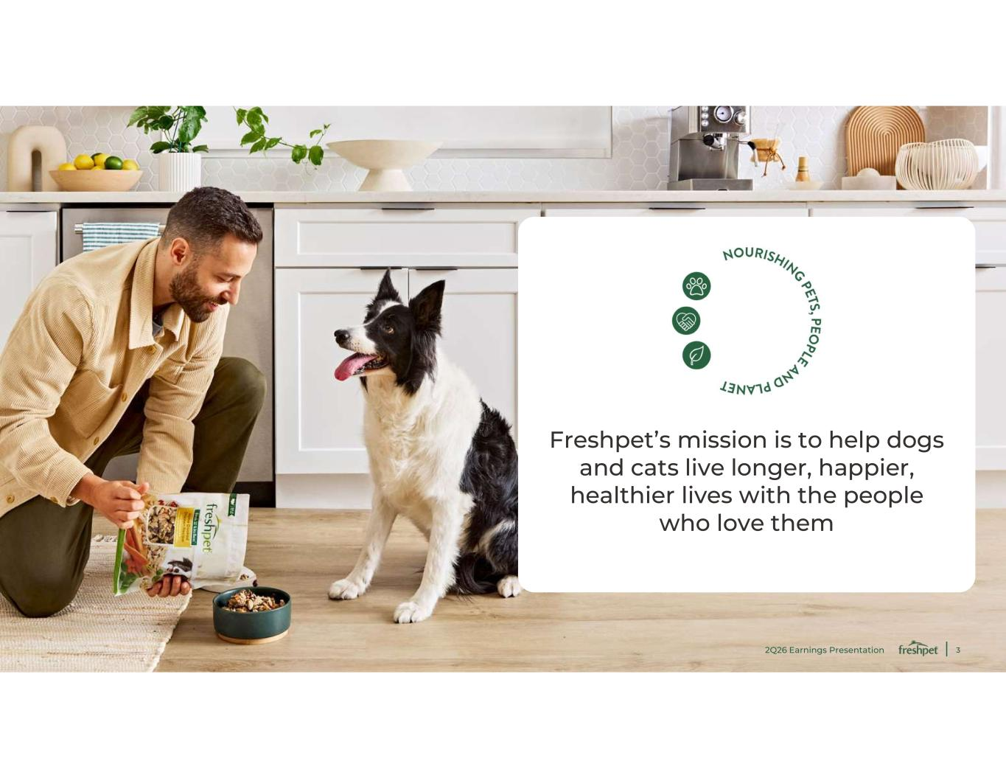
3 Freshpet’s mission is to help dogs and cats live longer, happier, healthier lives with the people who love them 2Q26 Earnings Presentation


4 Highlights

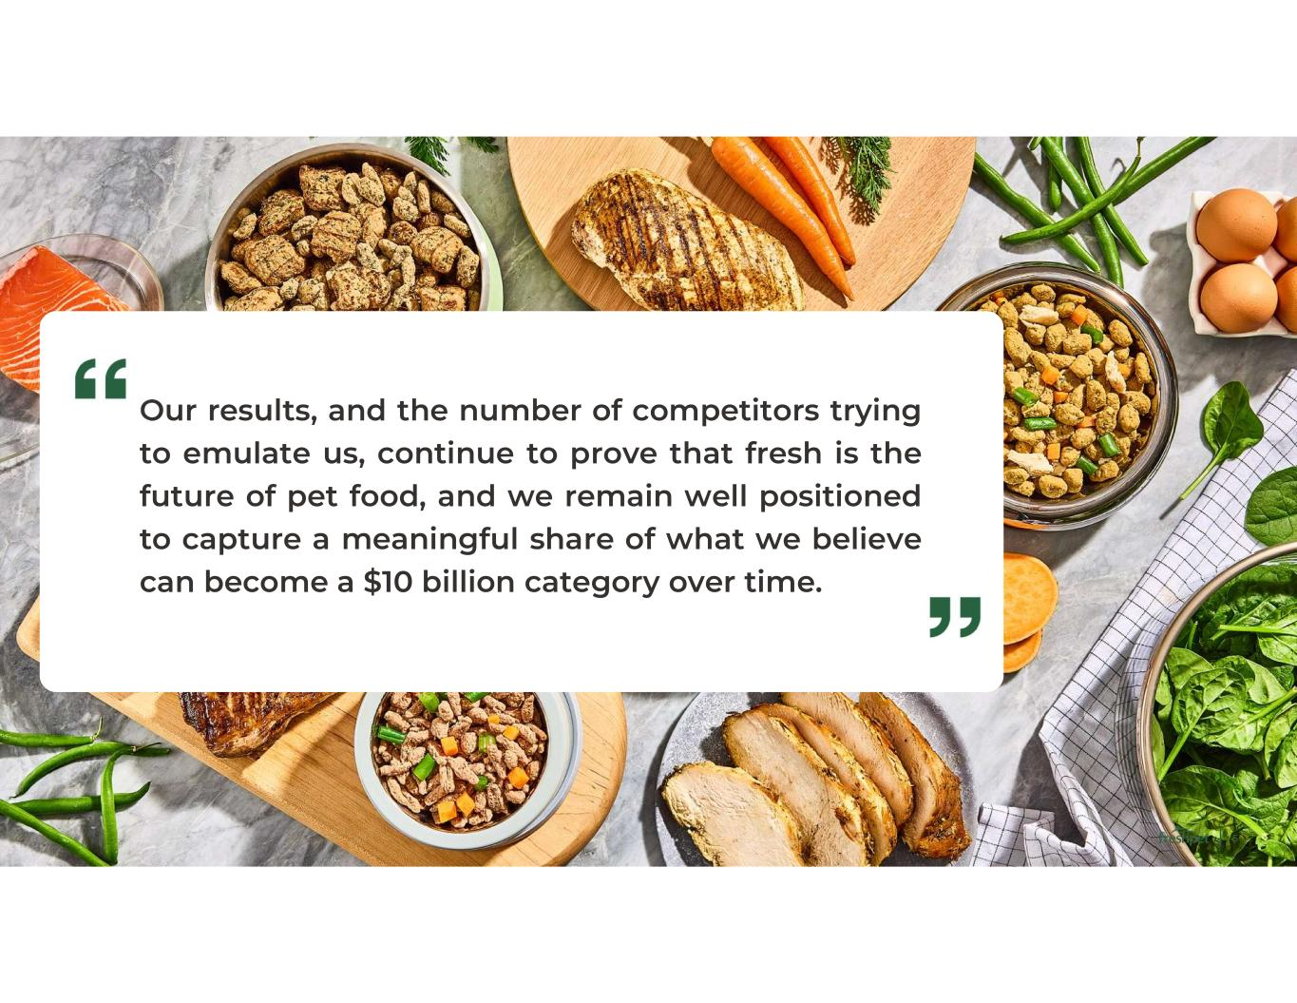
5 Our results, and the number of competitors trying to emulate us, continue to prove that fresh is the future of pet food, and we remain well positioned to capture a meaningful share of what we believe can become a $10 billion category over time.

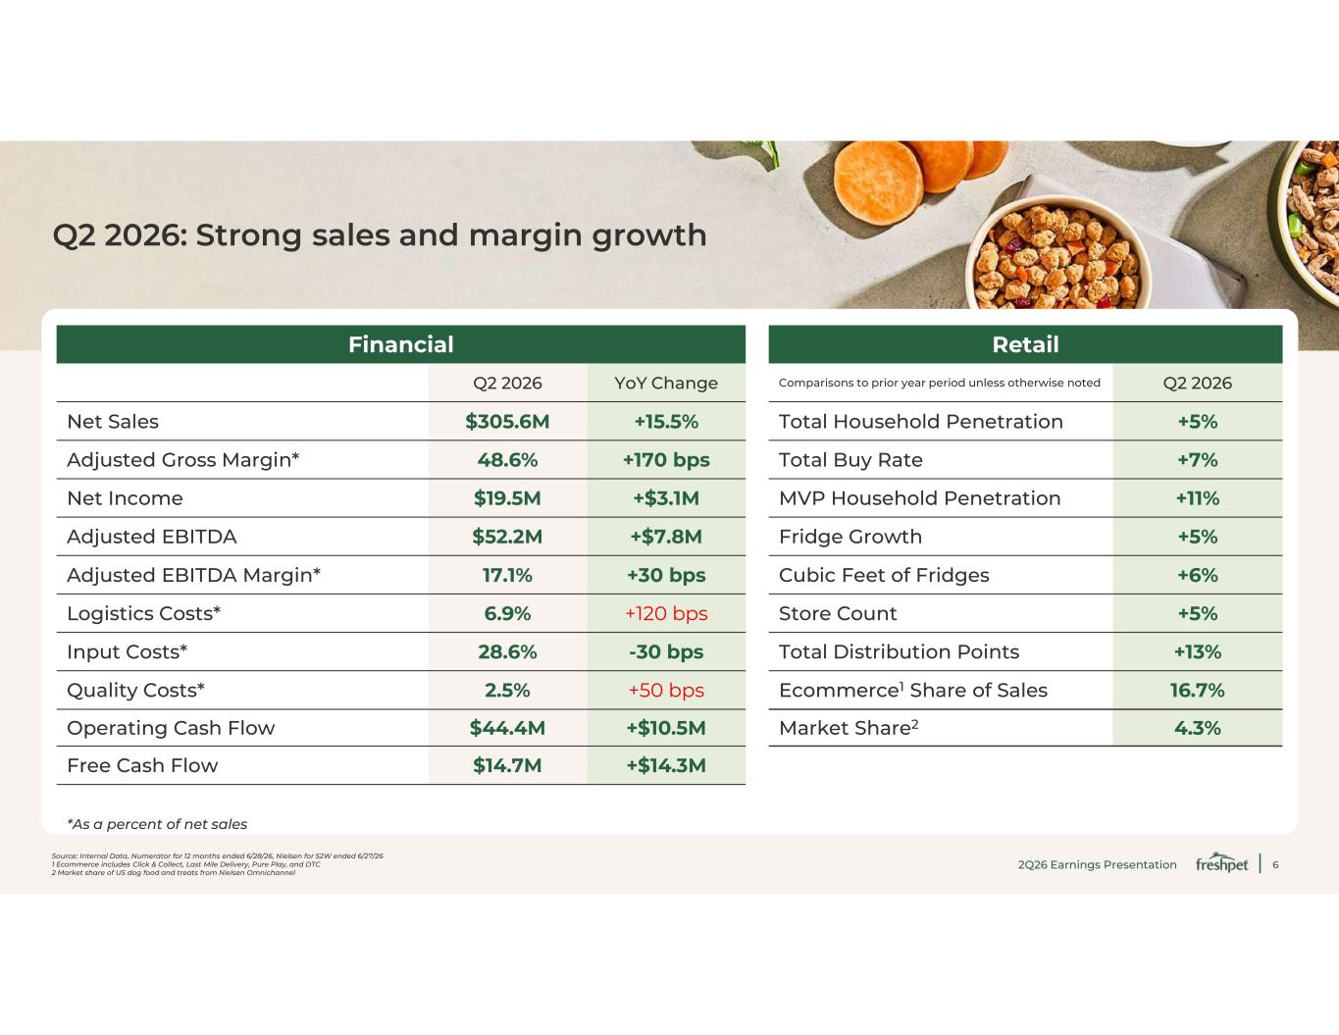
6 Source: Internal Data, Numerator for 12 months ended 6/28/26, Nielsen for 52W ended 6/27/26 1 Ecommerce includes Click & Collect, Last Mile Delivery, Pure Play, and DTC 2 Market share of US dog food and treats from Nielsen Omnichannel Q2 2026: Strong sales and margin growth RetailFinancial Q2 2026Comparisons to prior year period unless otherwise notedYoY ChangeQ2 2026 +5%Total Household Penetration+15.5%$305.6MNet Sales +7%Total Buy Rate+170 bps48.6%Adjusted Gross Margin* +11%MVP Household Penetration+$3.1M$19.5MNet Income +5%Fridge Growth+$7.8M$52.2MAdjusted EBITDA +6%Cubic Feet of Fridges+30 bps17.1%Adjusted EBITDA Margin* +5%Store Count+120 bps6.9%Logistics Costs* +13%Total Distribution Points-30 bps28.6%Input Costs* 16.7%Ecommerce1 Share of Sales+50 bps2.5%Quality Costs* 4.3%Market Share2+$10.5M$44.4MOperating Cash Flow +$14.3M$14.7MFree Cash Flow *As a percent of net sales 2Q26 Earnings Presentation

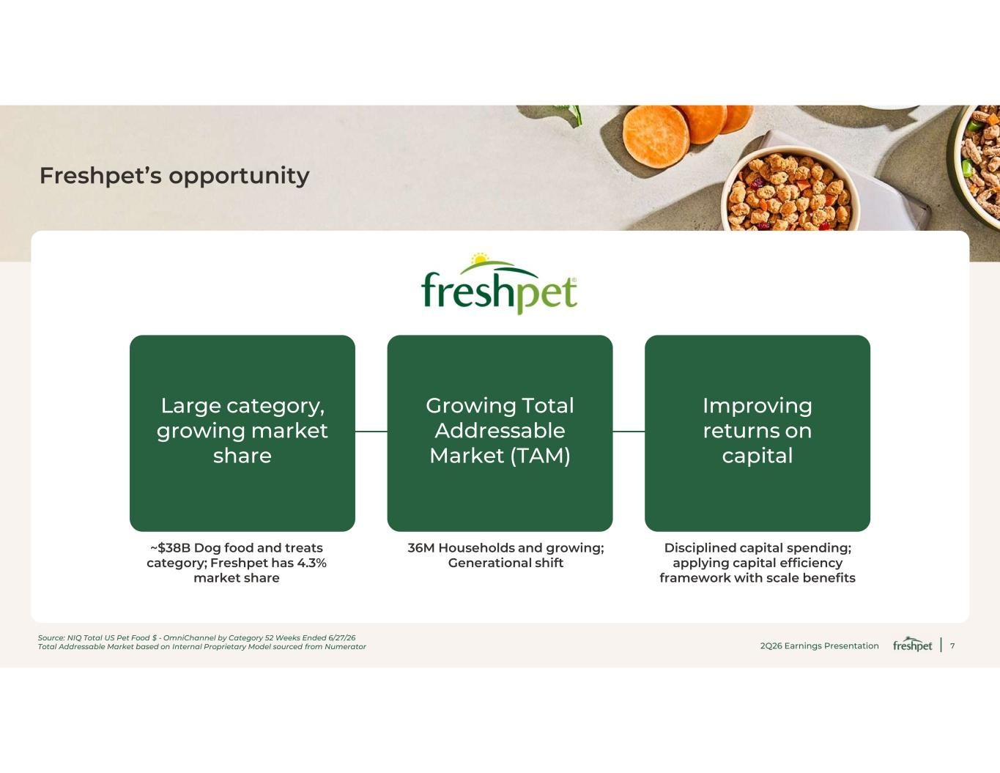
7 Freshpet’s opportunity Large category, growing market share Growing Total Addressable Market (TAM) Improving returns on capital Disciplined capital spending; applying capital efficiency framework with scale benefits 36M Households and growing; Generational shift ~$38B Dog food and treats category; Freshpet has 4.3% market share Source: NIQ Total US Pet Food $ - OmniChannel by Category 52 Weeks Ended 6/27/26 Total Addressable Market based on Internal Proprietary Model sourced from Numerator 2Q26 Earnings Presentation

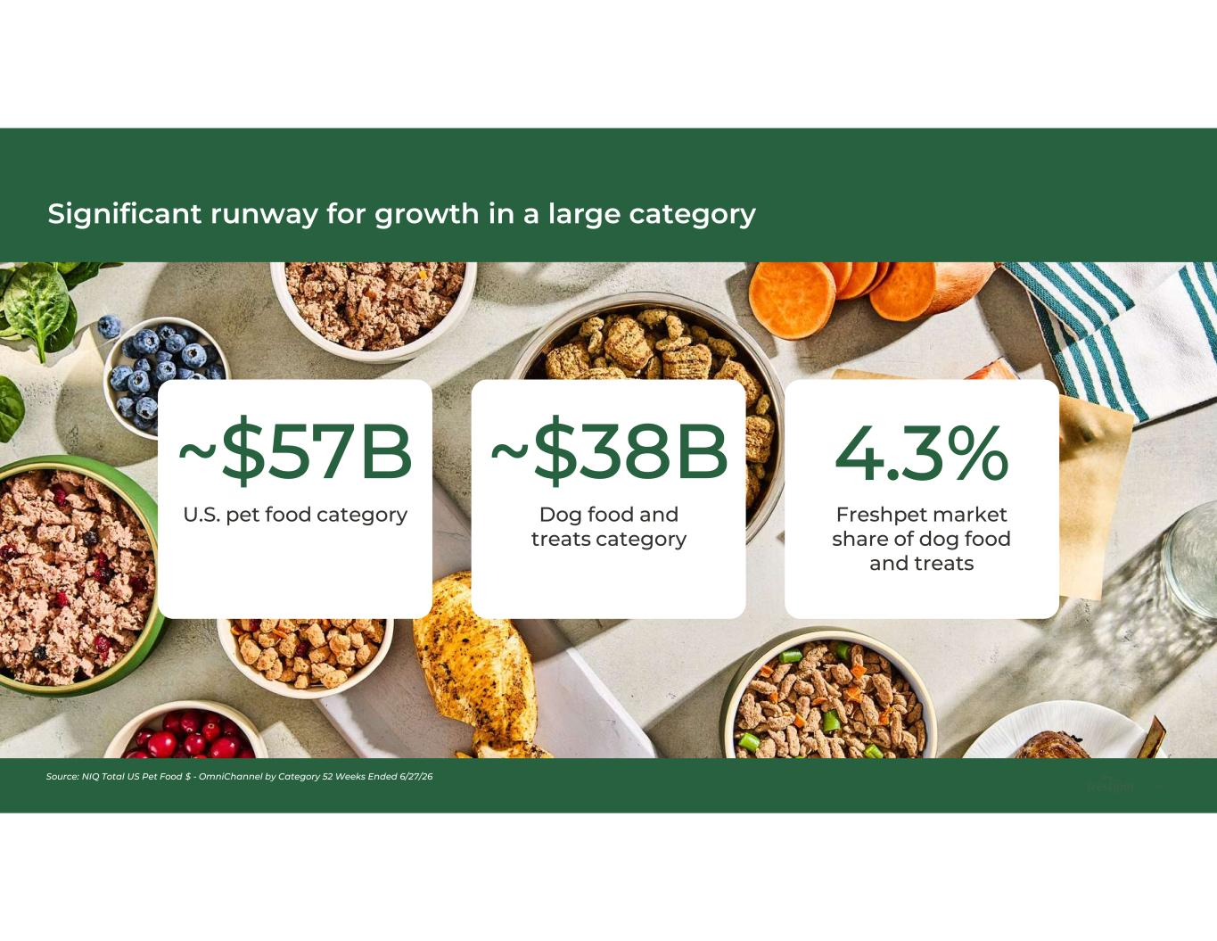
8 Significant runway for growth in a large category Source: NIQ Total US Pet Food $ - OmniChannel by Category 52 Weeks Ended 6/27/26 ~$57B U.S. pet food category ~$38B Dog food and treats category 4.3% Freshpet market share of dog food and treats

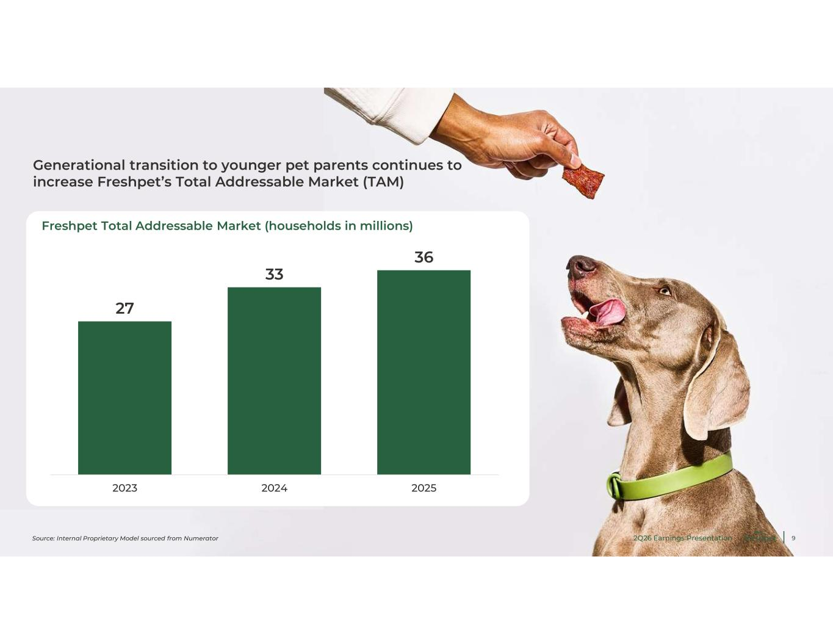
9 Generational transition to younger pet parents continues to increase Freshpet’s Total Addressable Market (TAM) 27 33 36 2023 2024 2025 Freshpet Total Addressable Market (households in millions) Source: Internal Proprietary Model sourced from Numerator 2Q26 Earnings Presentation

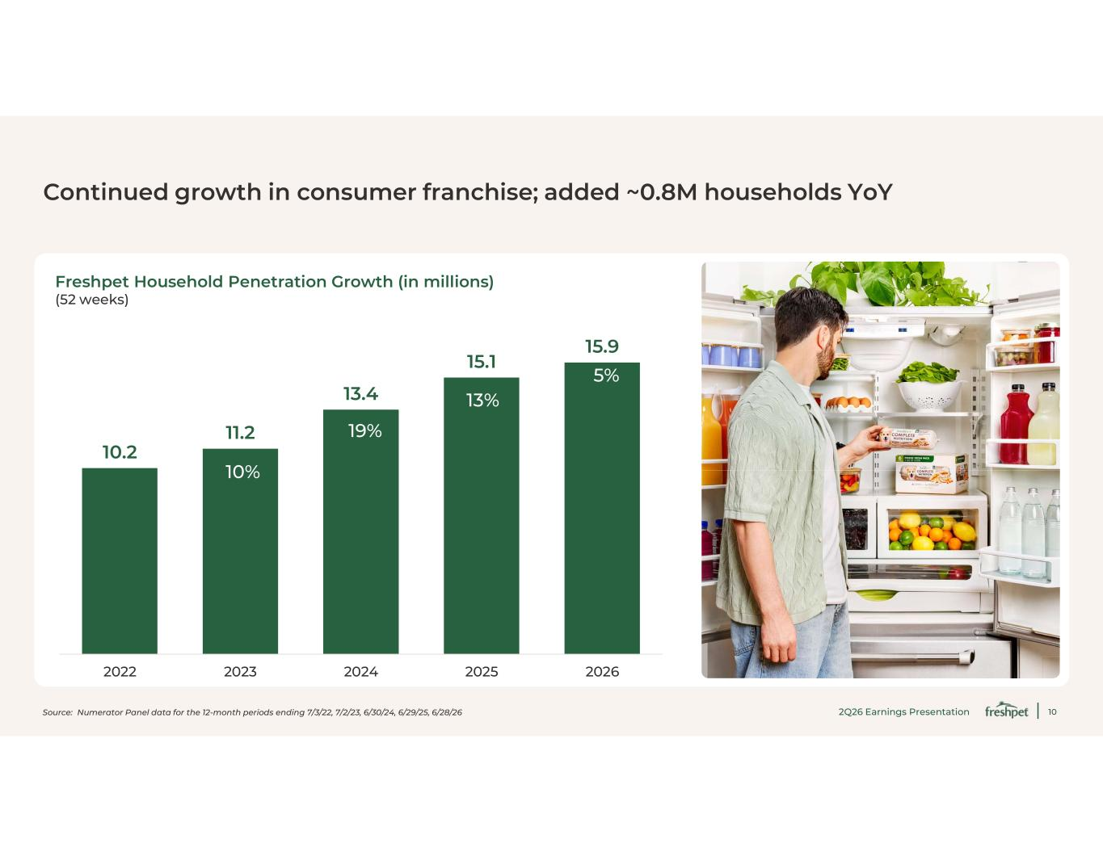
10 10.2 11.2 13.4 15.1 15.9 2022 2023 2024 2025 2026 Continued growth in consumer franchise; added ~0.8M households YoY Source: Numerator Panel data for the 12-month periods ending 7/3/22, 7/2/23, 6/30/24, 6/29/25, 6/28/26 Freshpet Household Penetration Growth (in millions) (52 weeks) 10% 19% 13% 5% 2Q26 Earnings Presentation

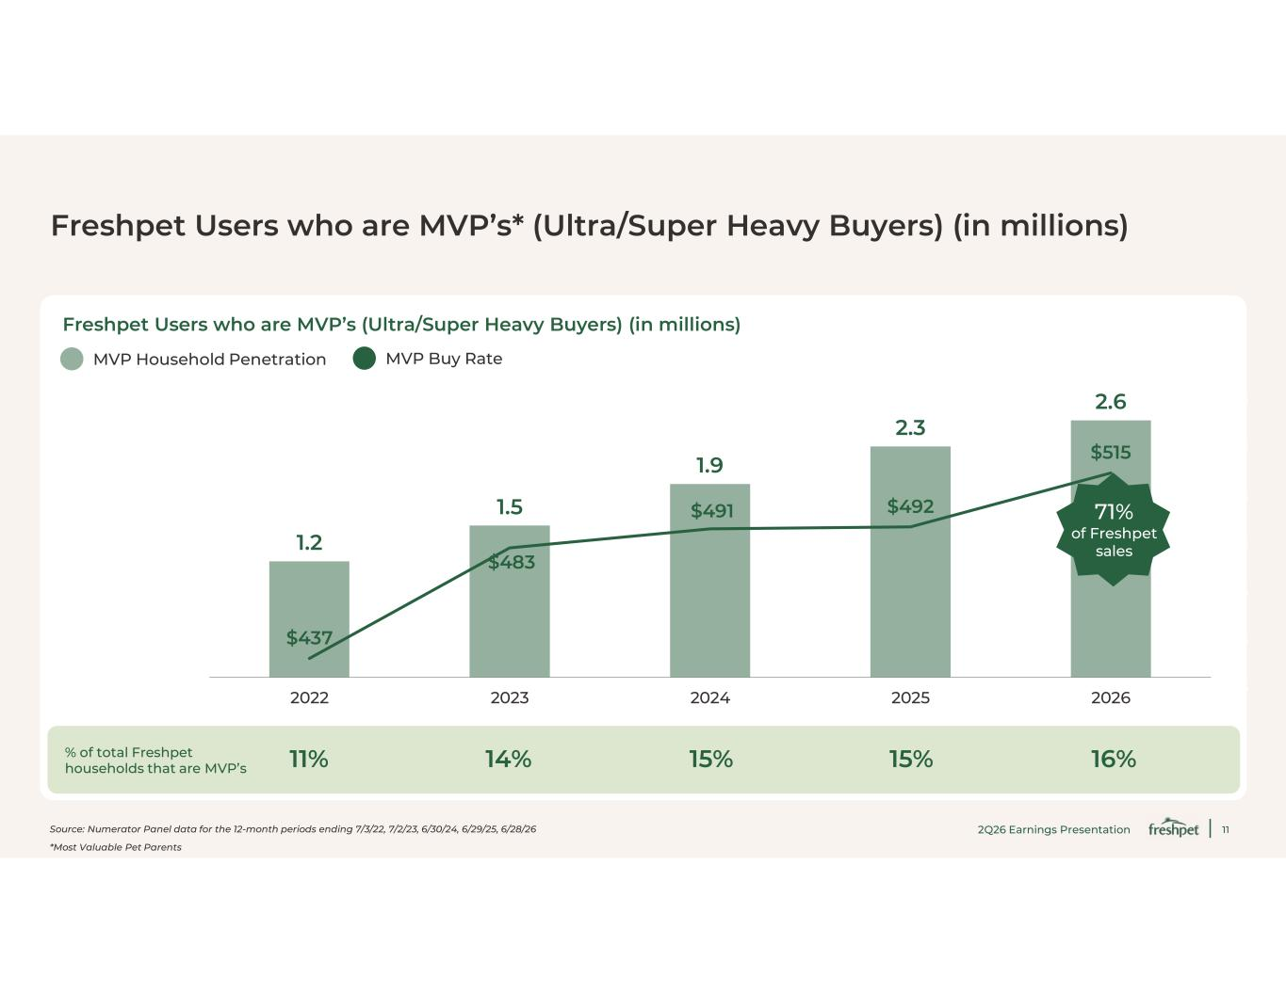
11 Freshpet Users who are MVP’s* (Ultra/Super Heavy Buyers) (in millions) Source: Numerator Panel data for the 12-month periods ending 7/3/22, 7/2/23, 6/30/24, 6/29/25, 6/28/26 *Most Valuable Pet Parents Freshpet Users who are MVP’s (Ultra/Super Heavy Buyers) (in millions) 1.2 1.5 1.9 2.3 2.6 $437 $483 $491 $492 $515 $425 $445 $465 $485 $505 $525 $545 -0.1 0.4 0.9 1.4 1.9 2.4 2.9 2022 2023 2024 2025 2026 MVP Household Penetration MVP Buy Rate 71% of Freshpet sales % of total Freshpet households that are MVP’s 11% 14% 15% 15% 16% 2Q26 Earnings Presentation

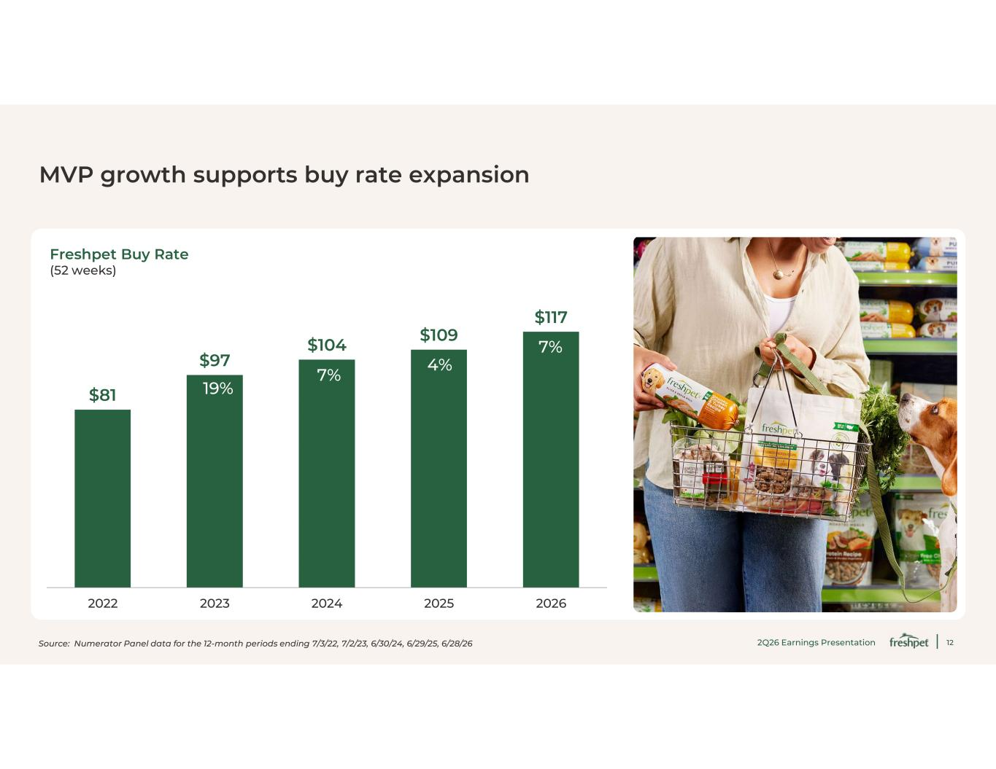
12 MVP growth supports buy rate expansion Freshpet Buy Rate (52 weeks) $81 $97 $104 $109 $117 2022 2023 2024 2025 2026 Source: Numerator Panel data for the 12-month periods ending 7/3/22, 7/2/23, 6/30/24, 6/29/25, 6/28/26 19% 7% 4% 7% 2Q26 Earnings Presentation

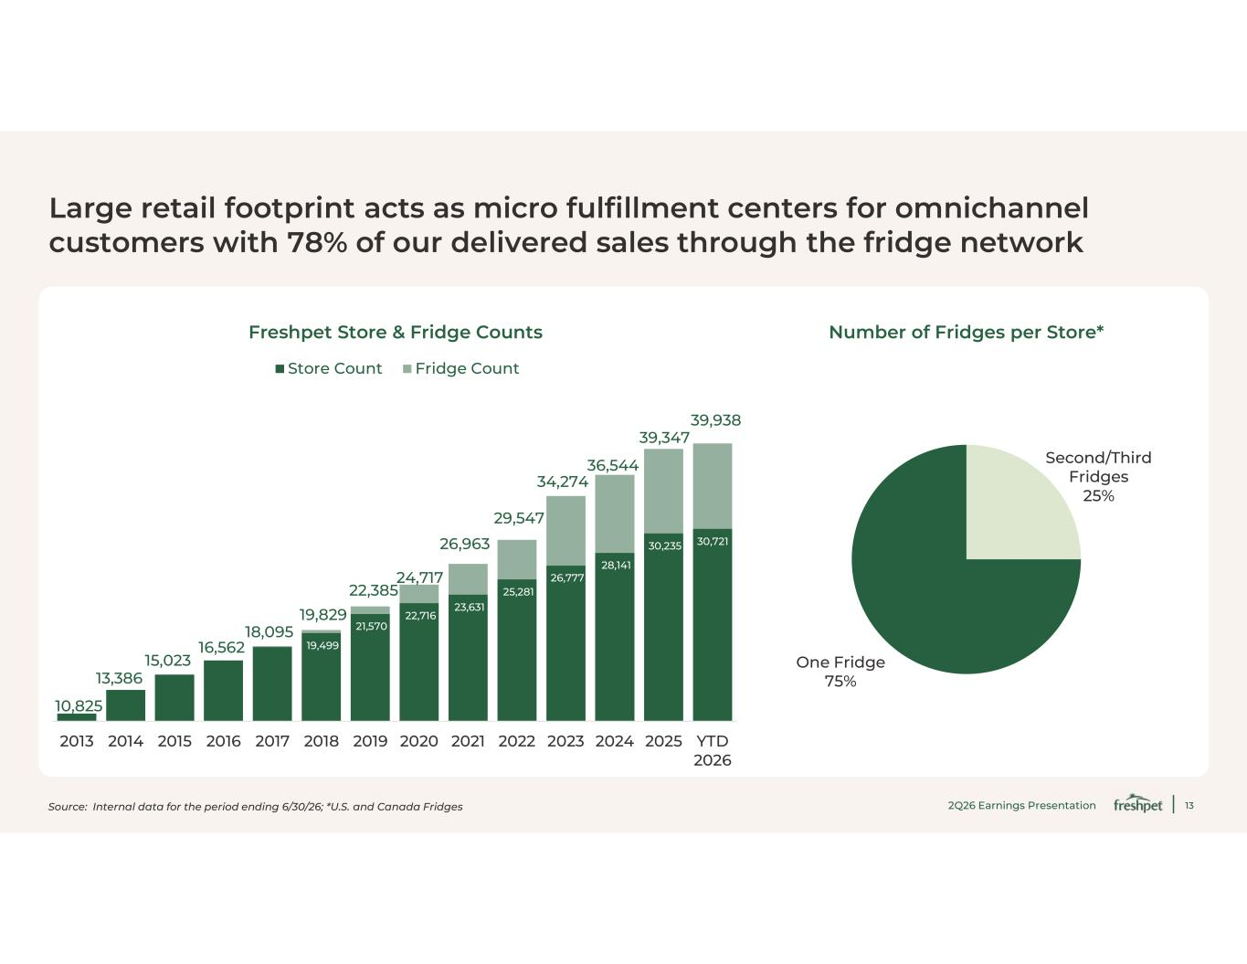
13 Large retail footprint acts as micro fulfillment centers for omnichannel customers with 78% of our delivered sales through the fridge network Second/Third Fridges 25% One Fridge 75% 19,499 21,570 22,716 23,631 25,281 26,777 28,141 30,235 30,721 10,825 13,386 15,023 16,562 18,095 19,829 22,385 24,717 26,963 29,547 34,274 36,544 39,347 39,938 2013 2014 2015 2016 2017 2018 2019 2020 2021 2022 2023 2024 2025 YTD 2026 Store Count Fridge Count Freshpet Store & Fridge Counts Number of Fridges per Store* Source: Internal data for the period ending 6/30/26; *U.S. and Canada Fridges 2Q26 Earnings Presentation

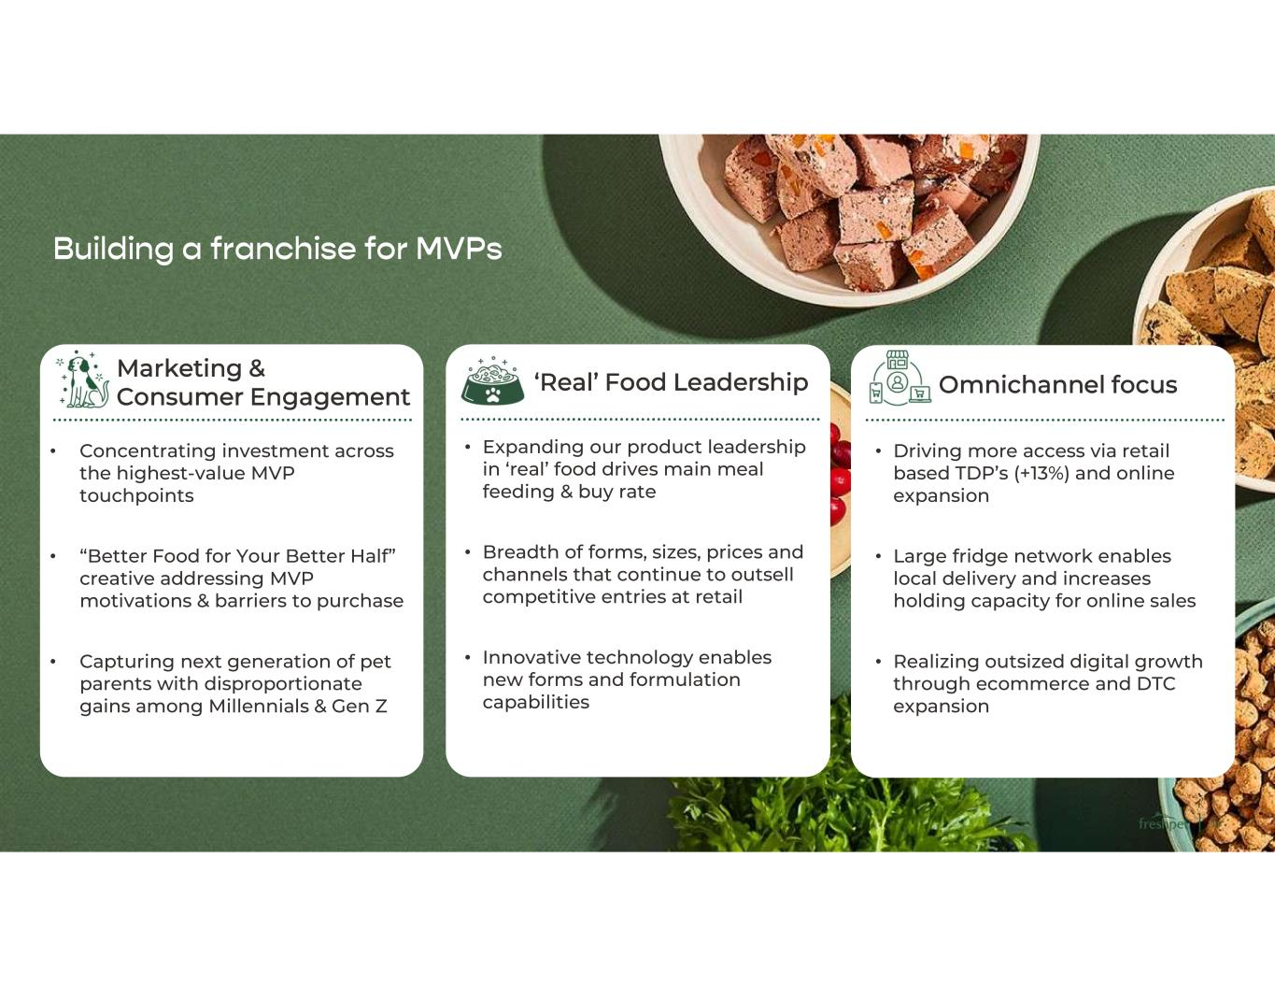
14 Building a franchise for MVPs • Driving more access via retail based TDP’s (+13%) and online expansion • Large fridge network enables local delivery and increases holding capacity for online sales • Realizing outsized digital growth through ecommerce and DTC expansion • Concentrating investment across the highest-value MVP touchpoints • “Better Food for Your Better Half” creative addressing MVP motivations & barriers to purchase • Capturing next generation of pet parents with disproportionate gains among Millennials & Gen Z Omnichannel focus Marketing & Consumer Engagement ‘Real’ Food Leadership • Expanding our product leadership in ‘real’ food drives main meal feeding & buy rate • Breadth of forms, sizes, prices and channels that continue to outsell competitive entries at retail • Innovative technology enables new forms and formulation capabilities

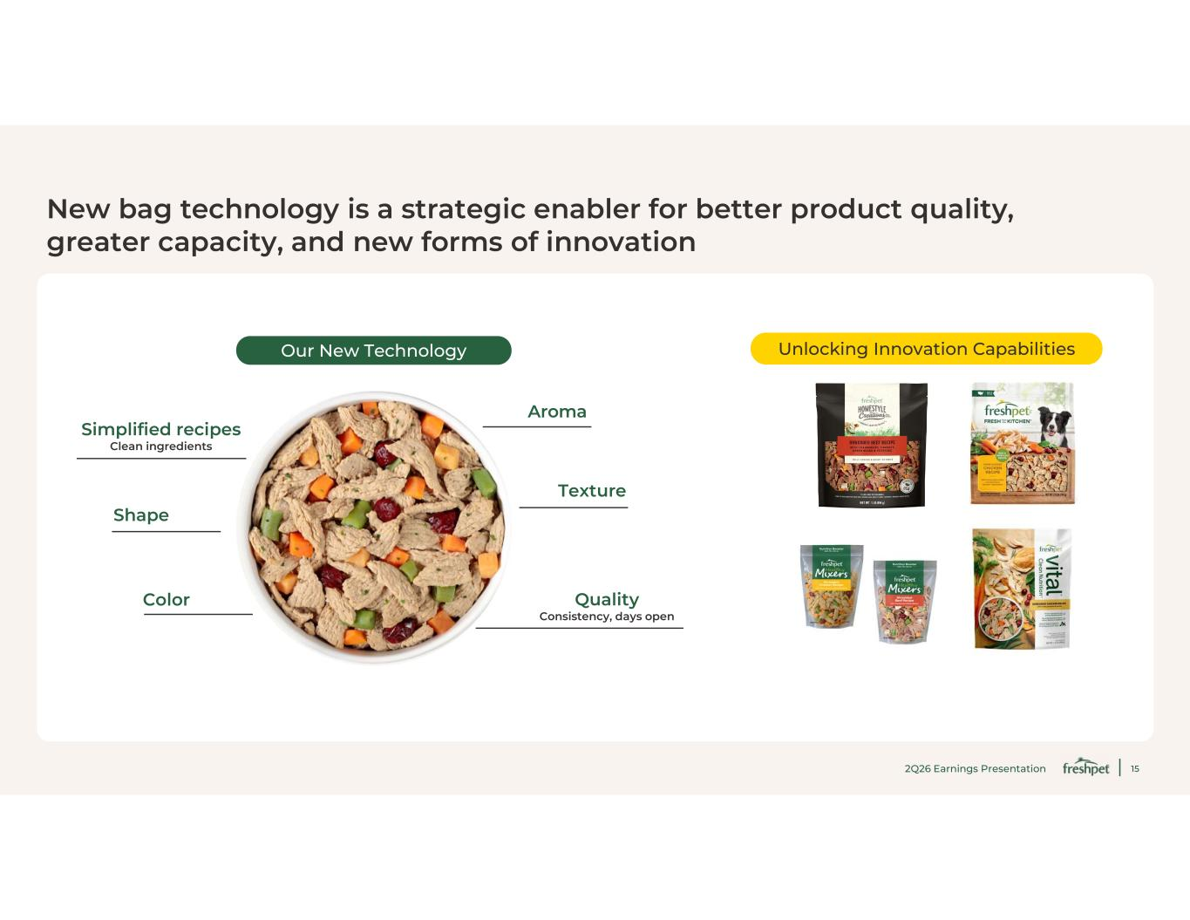
15 New bag technology is a strategic enabler for better product quality, greater capacity, and new forms of innovation Our New Technology Unlocking Innovation Capabilities 2Q26 Earnings Presentation Texture Shape Aroma Quality Consistency, days open Color Simplified recipes Clean ingredients

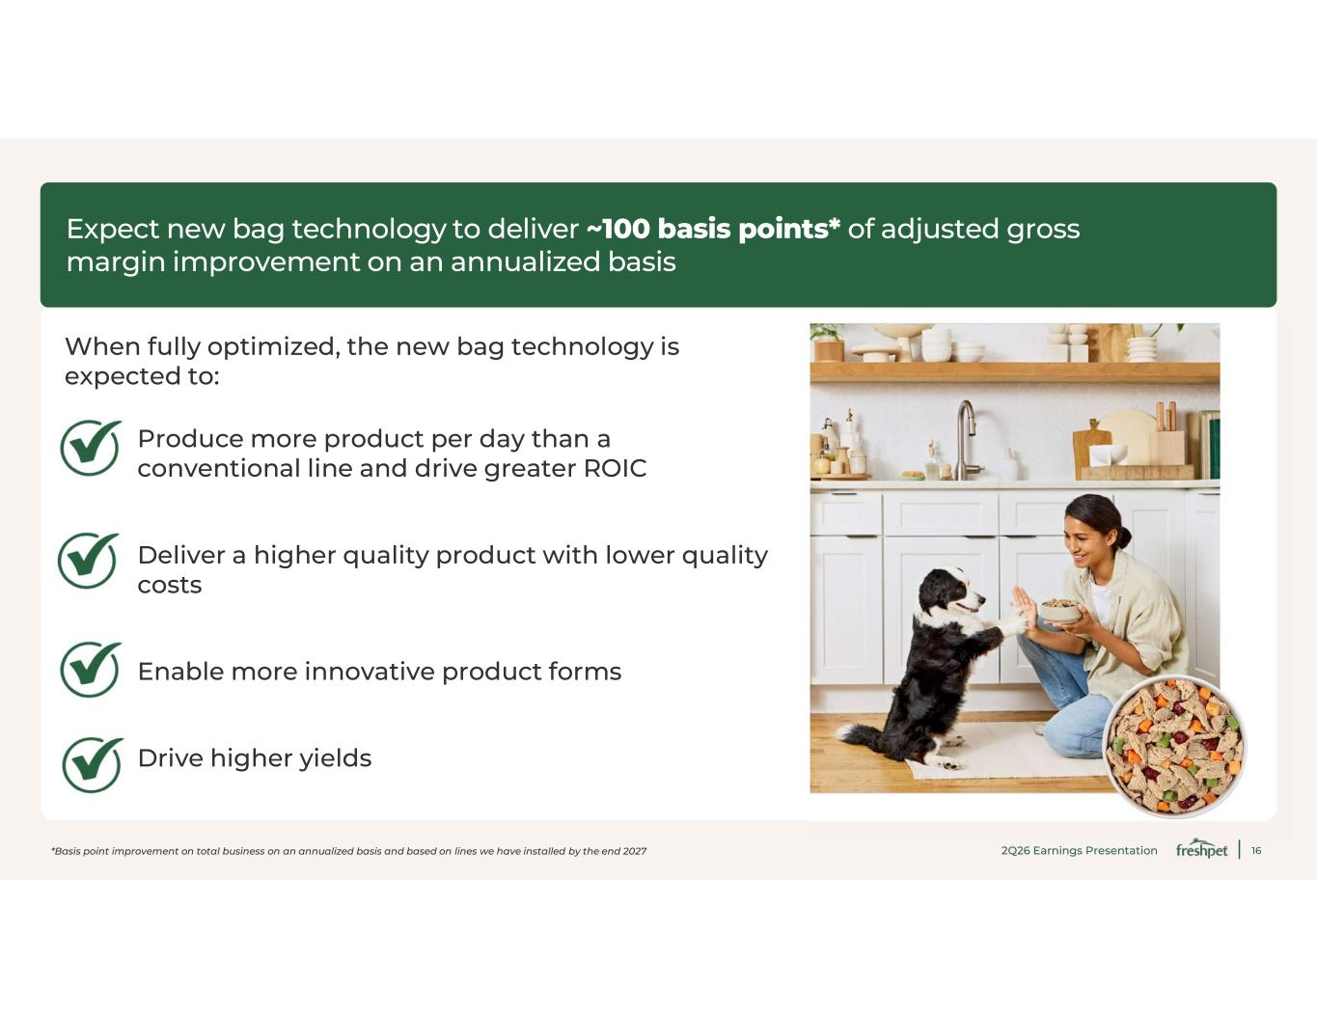
16 Expect new bag technology to deliver ~100 basis points* of adjusted gross margin improvement on an annualized basis When fully optimized, the new bag technology is expected to: *Basis point improvement on total business on an annualized basis and based on lines we have installed by the end 2027 Produce more product per day than a conventional line and drive greater ROIC Deliver a higher quality product with lower quality costs Enable more innovative product forms Drive higher yields 2Q26 Earnings Presentation

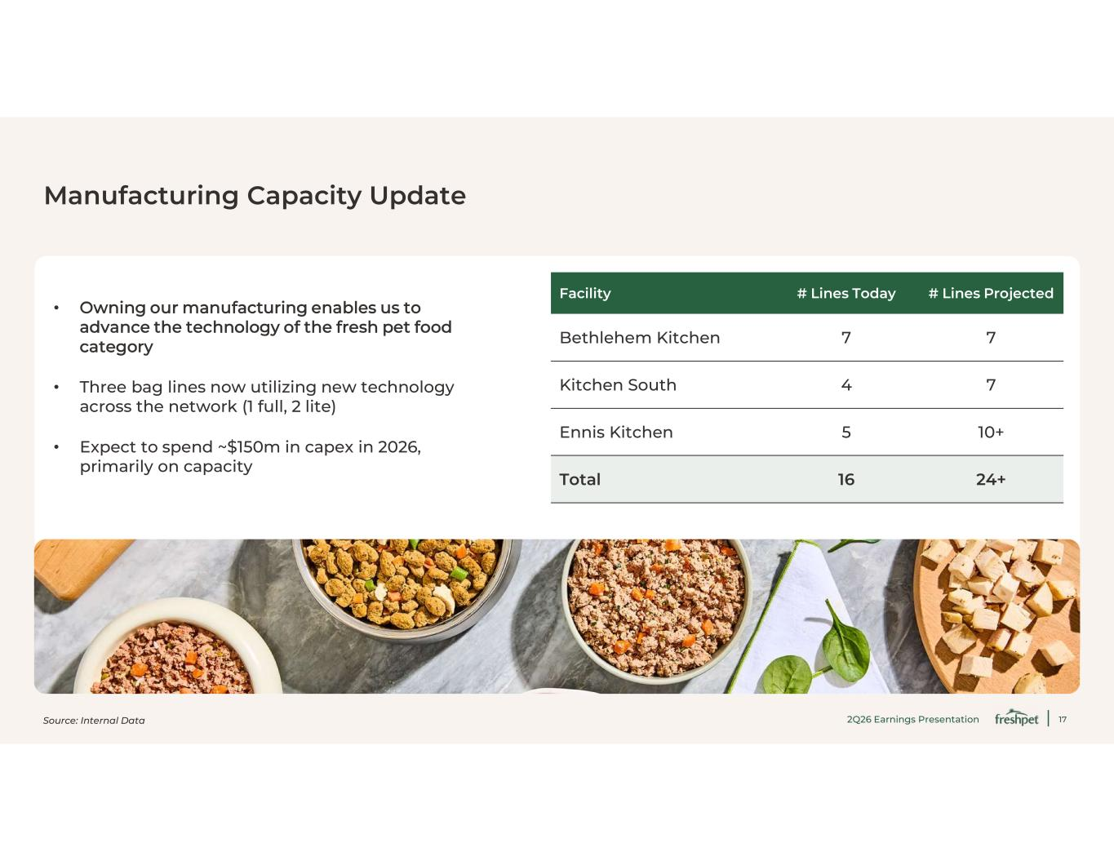
17 Manufacturing Capacity Update Source: Internal Data • Owning our manufacturing enables us to advance the technology of the fresh pet food category • Three bag lines now utilizing new technology across the network (1 full, 2 lite) • Expect to spend ~$150m in capex in 2026, primarily on capacity # Lines Projected# Lines TodayFacility 77Bethlehem Kitchen 74Kitchen South 10+5Ennis Kitchen 24+16Total 2Q26 Earnings Presentation

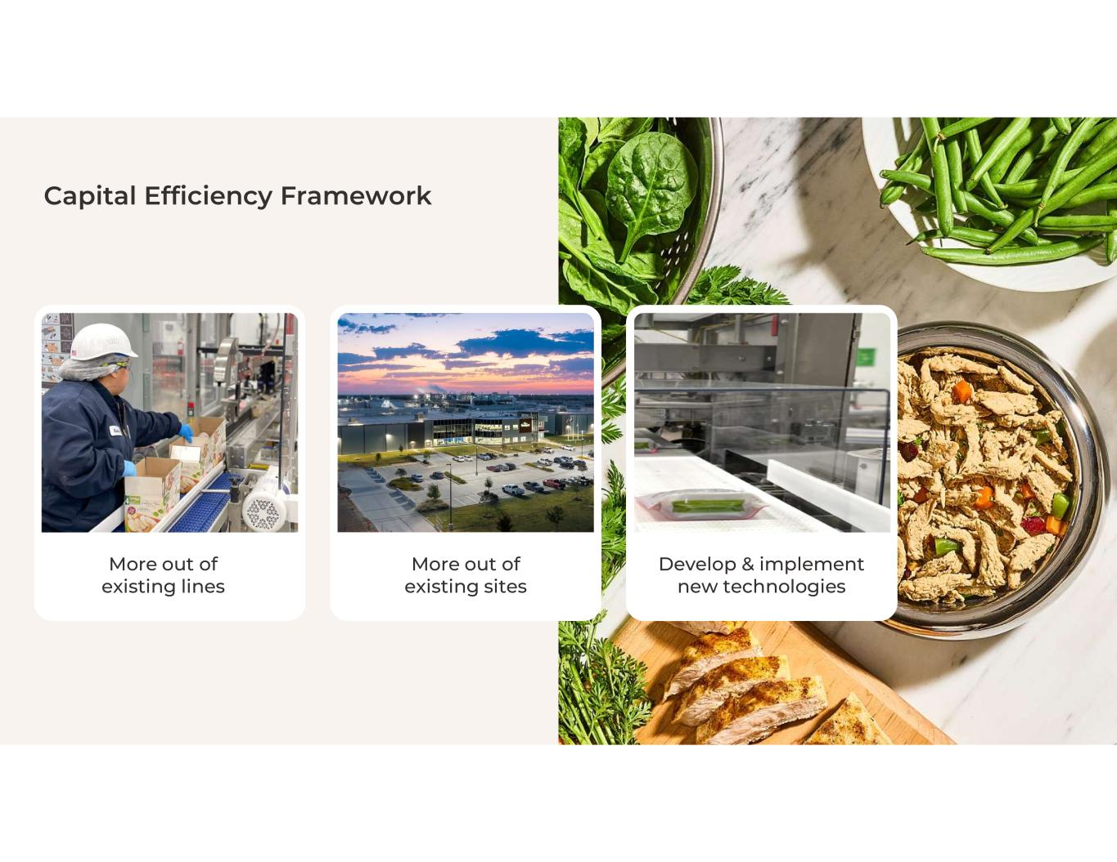
18 Capital Efficiency Framework More out of existing lines More out of existing sites Develop & implement new technologies

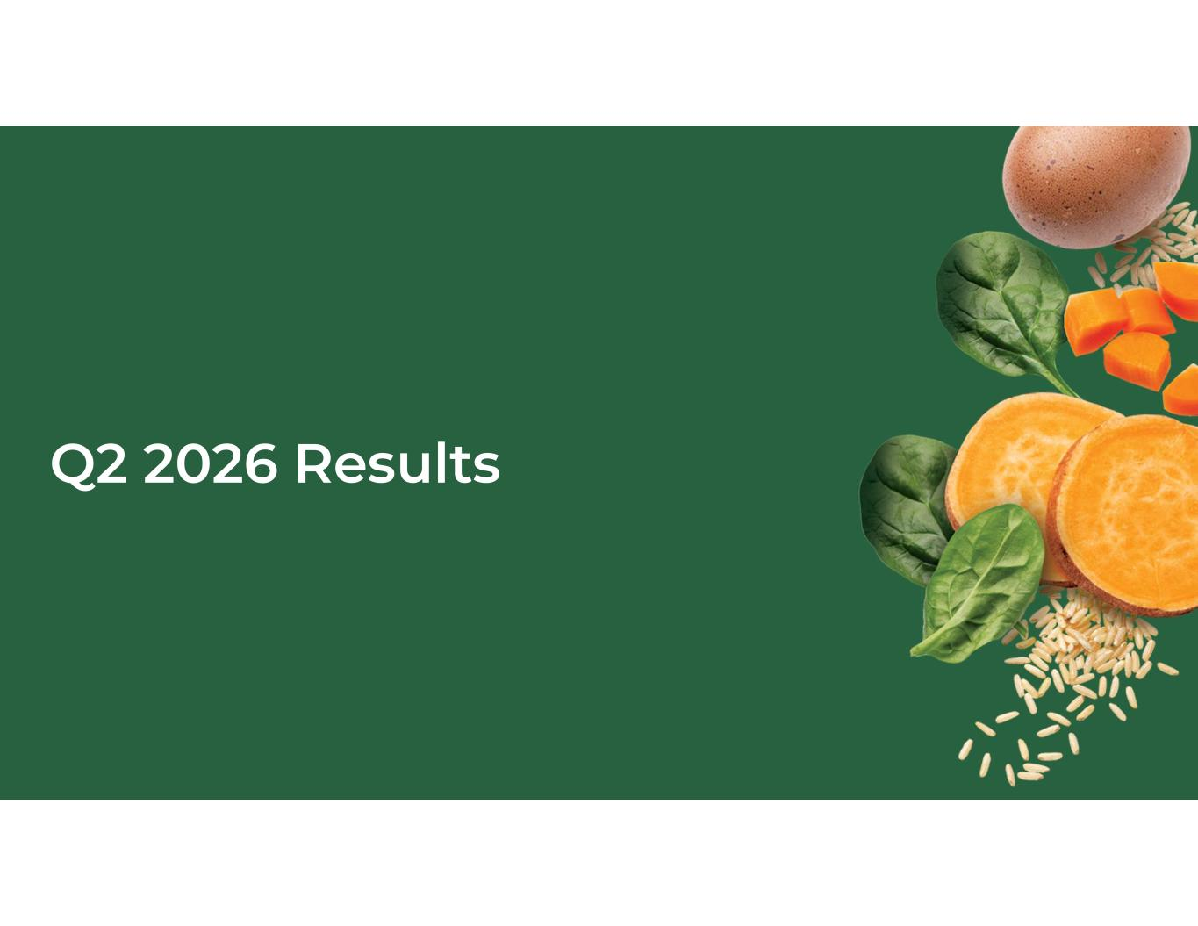
19 Q2 2026 Results

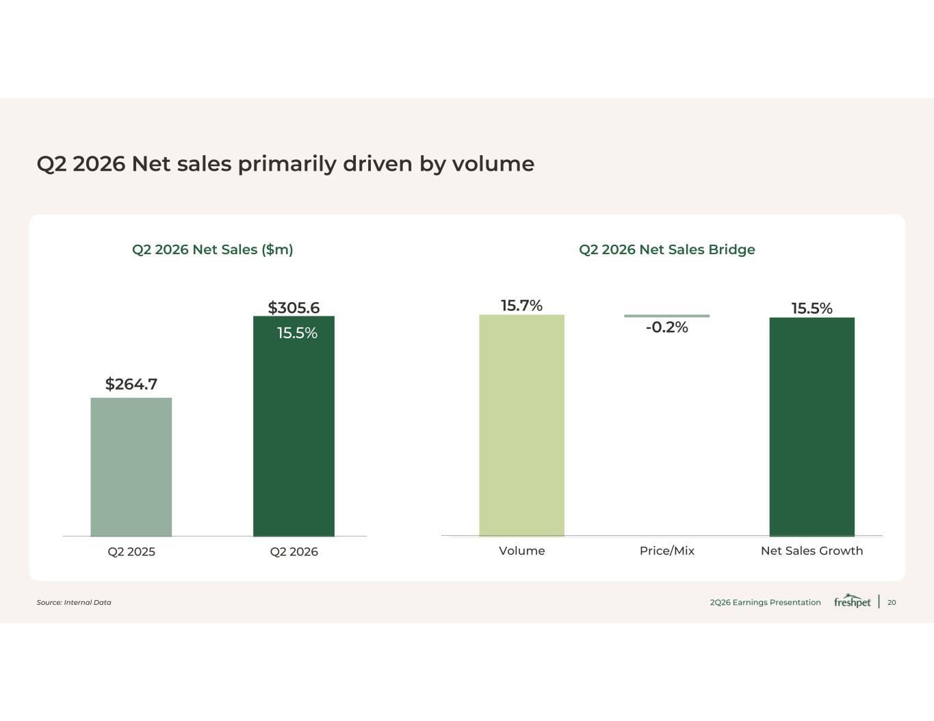
20 Q2 2026 Net sales primarily driven by volume $264.7 $305.6 Q2 2025 Q2 2026 15.5% Source: Internal Data 15.7% -0.2% 15.5% Volume Price/Mix Net Sales Growth Q2 2026 Net Sales ($m) Q2 2026 Net Sales Bridge 2Q26 Earnings Presentation

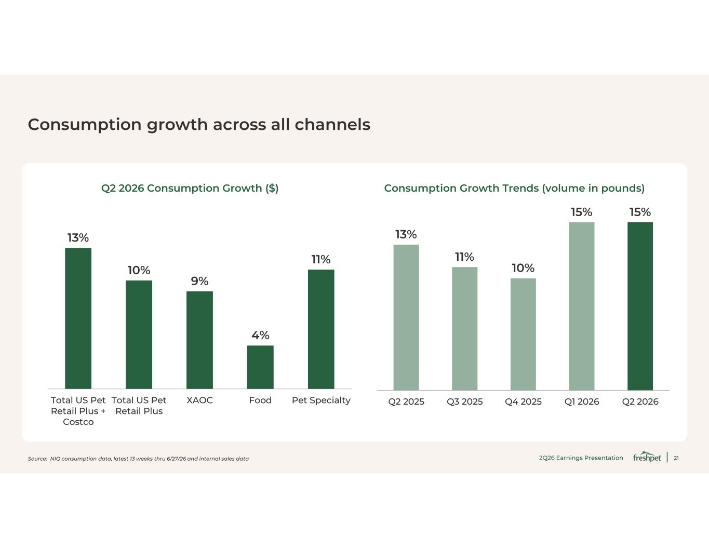
21 Consumption growth across all channels Source: NIQ consumption data, latest 13 weeks thru 6/27/26 and internal sales data Q2 2026 Consumption Growth ($) Consumption Growth Trends (volume in pounds) 13% 10% 9% 4% 11% Total US Pet Retail Plus + Costco Total US Pet Retail Plus XAOC Food Pet Specialty 13% 11% 10% 15% 15% Q2 2025 Q3 2025 Q4 2025 Q1 2026 Q2 2026 2Q26 Earnings Presentation

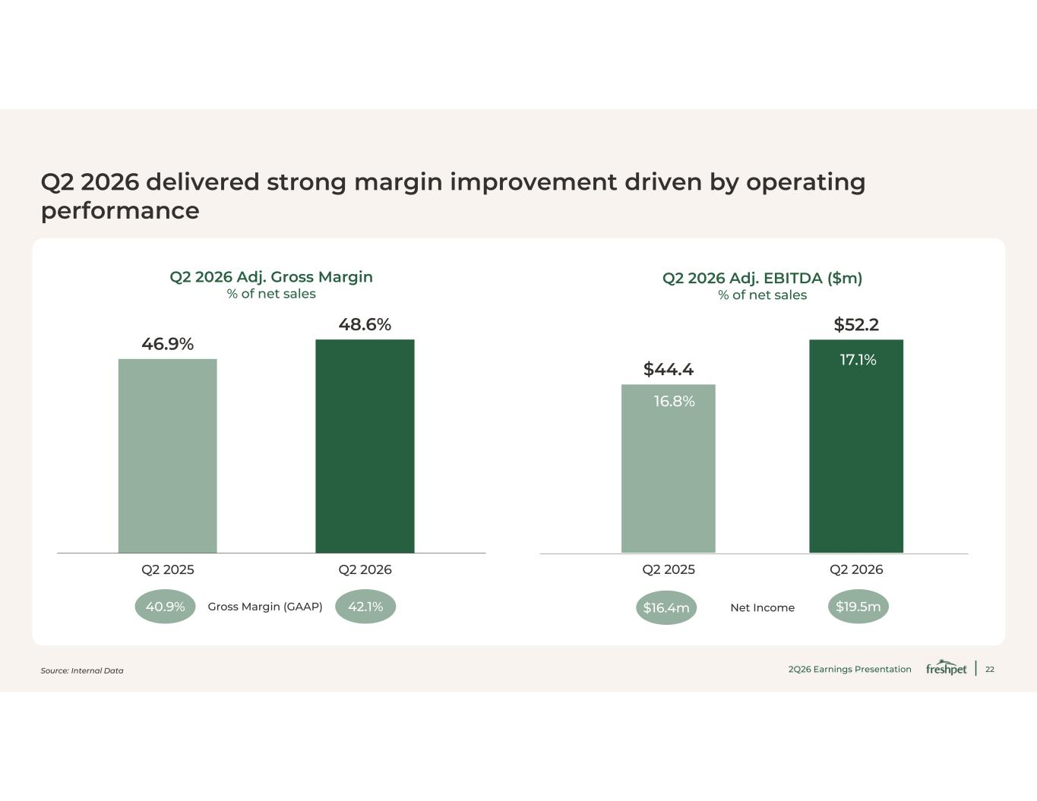
22 Q2 2026 delivered strong margin improvement driven by operating performance Q2 2026 Adj. Gross Margin % of net sales Q2 2026 Adj. EBITDA ($m) % of net sales 46.9% 48.6% Q2 2025 Q2 2026 $44.4 $52.2 Q2 2025 Q2 2026 16.8% 17.1% Net Income$16.4m $19.5mGross Margin (GAAP) 42.1%40.9% Source: Internal Data 2Q26 Earnings Presentation


23 Guidance

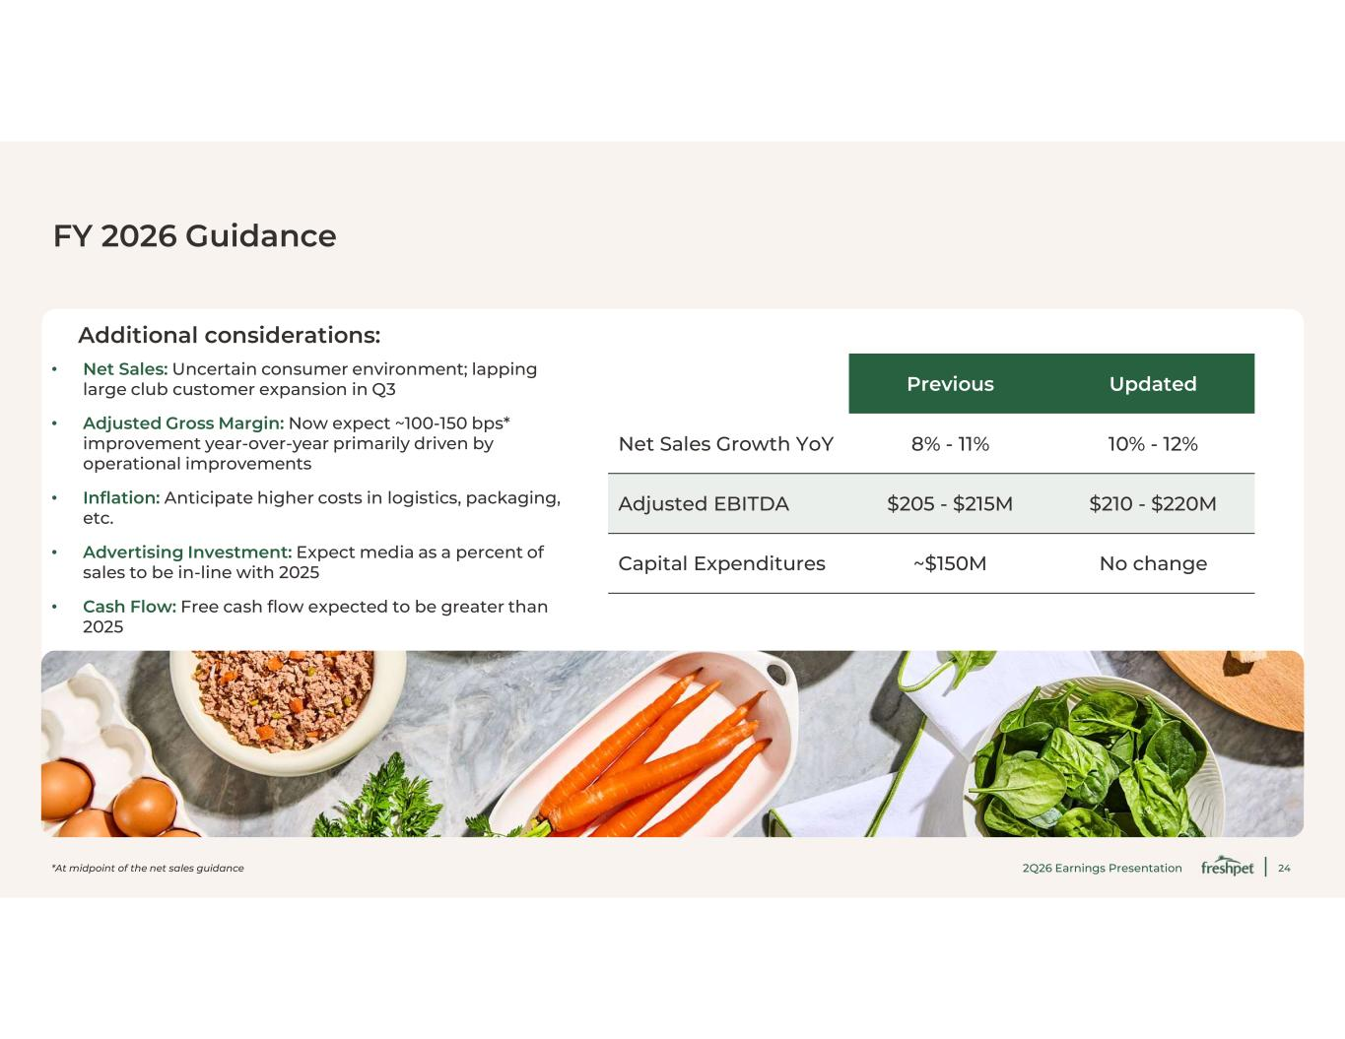
24 FY 2026 Guidance Additional considerations: • Net Sales: Uncertain consumer environment; lapping large club customer expansion in Q3 • Adjusted Gross Margin: Now expect ~100-150 bps* improvement year-over-year primarily driven by operational improvements • Inflation: Anticipate higher costs in logistics, packaging, etc. • Advertising Investment: Expect media as a percent of sales to be in-line with 2025 • Cash Flow: Free cash flow expected to be greater than 2025 UpdatedPrevious 10% - 12%8% - 11%Net Sales Growth YoY $210 - $220M$205 - $215MAdjusted EBITDA No change~$150MCapital Expenditures 2Q26 Earnings Presentation*At midpoint of the net sales guidance

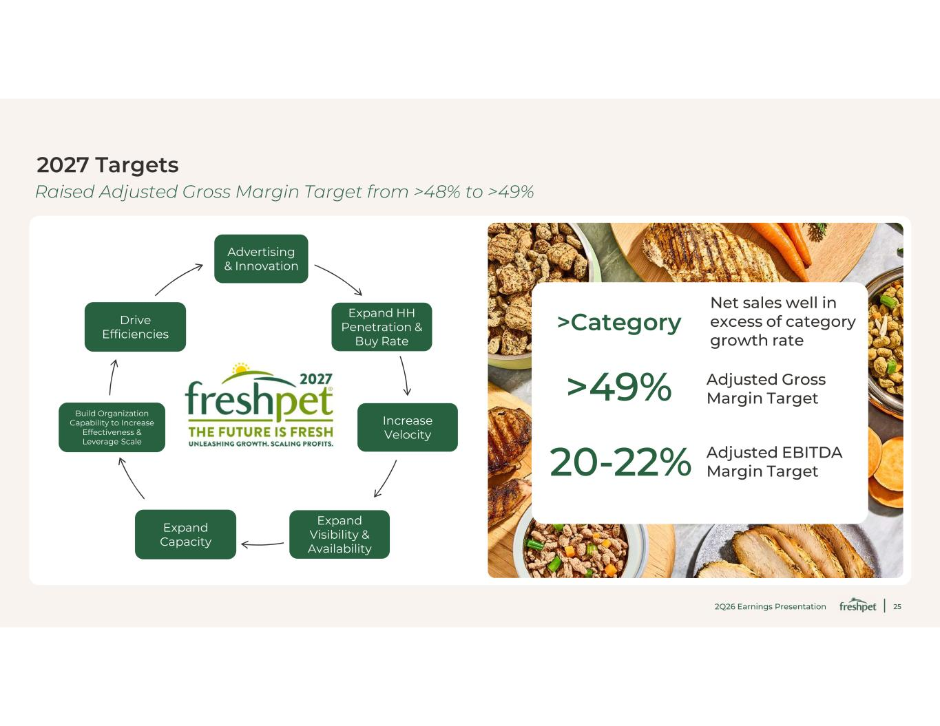
25 2027 Targets Expand HH Penetration & Buy Rate Increase Velocity Advertising & Innovation Expand Visibility & Availability Drive Efficiencies Build Organization Capability to Increase Effectiveness & Leverage Scale Expand Capacity >49% Adjusted Gross Margin Target 20-22% Adjusted EBITDA Margin Target Net sales well in excess of category growth rate >Category 2Q26 Earnings Presentation Raised Adjusted Gross Margin Target from >48% to >49%


26 Capital Spending, Cash Flow & Liquidity

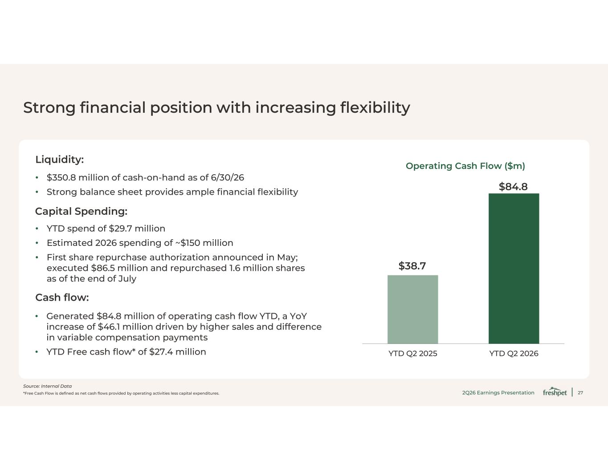
27 Strong financial position with increasing flexibility Source: Internal Data Operating Cash Flow ($m) $38.7 $84.8 YTD Q2 2025 YTD Q2 2026 Capital Spending: • YTD spend of $29.7 million • Estimated 2026 spending of ~$150 million • First share repurchase authorization announced in May; executed $86.5 million and repurchased 1.6 million shares as of the end of July Cash flow: • Generated $84.8 million of operating cash flow YTD, a YoY increase of $46.1 million driven by higher sales and difference in variable compensation payments • YTD Free cash flow* of $27.4 million Liquidity: • $350.8 million of cash-on-hand as of 6/30/26 • Strong balance sheet provides ample financial flexibility *Free Cash Flow is defined as net cash flows provided by operating activities less capital expenditures. 2Q26 Earnings Presentation

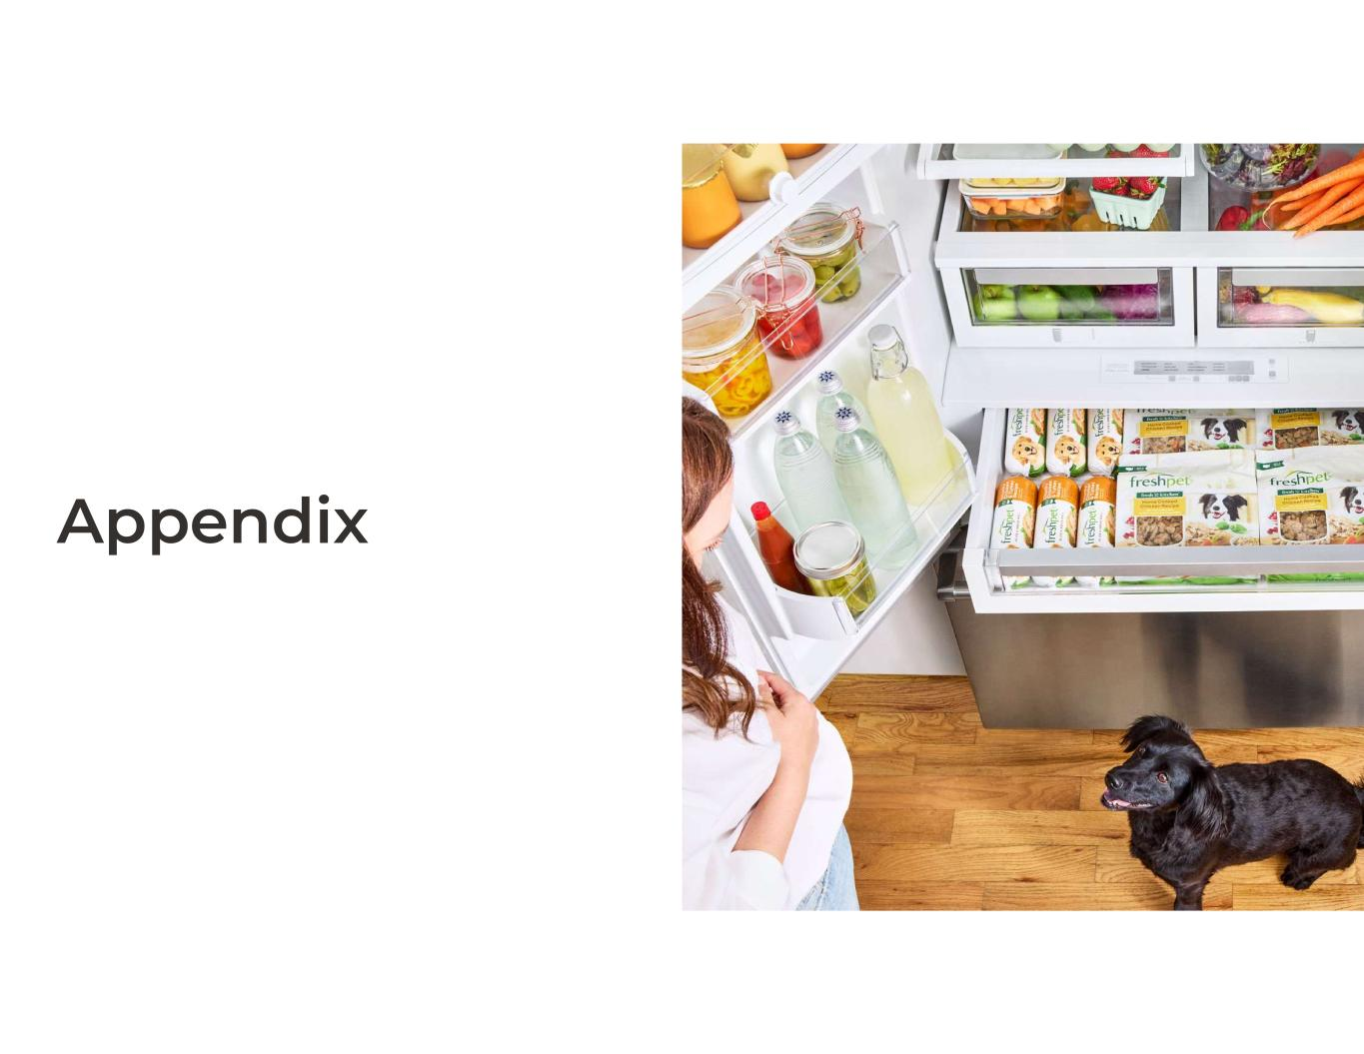
28 Appendix

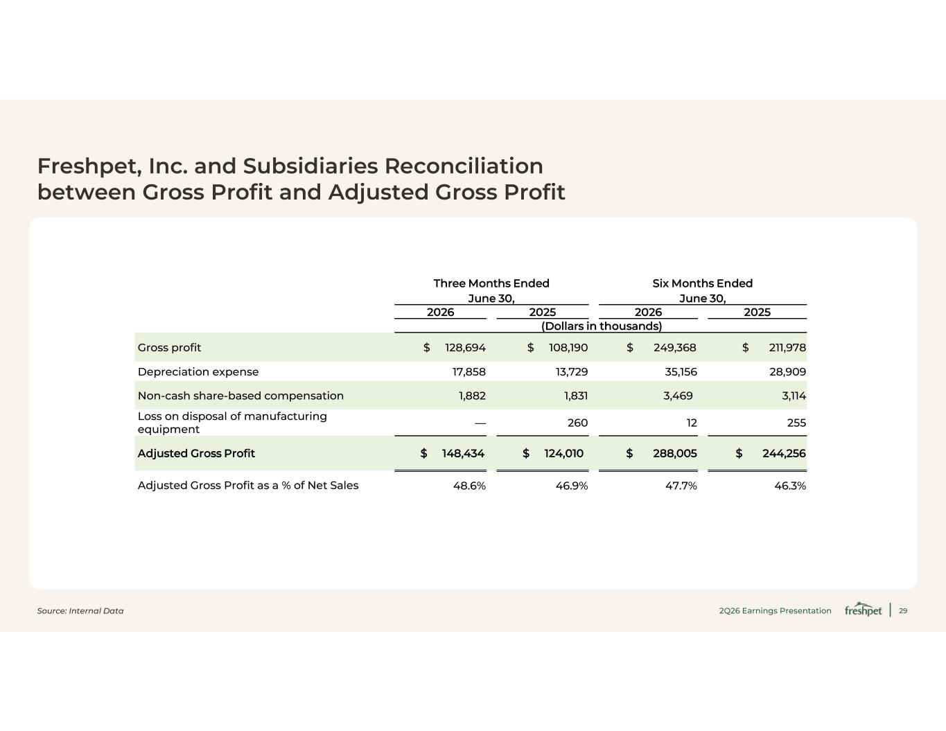
29 Freshpet, Inc. and Subsidiaries Reconciliation between Gross Profit and Adjusted Gross Profit Source: Internal Data 2Q26 Earnings Presentation Six Months Ended June 30, Three Months Ended June 30, 2025202620252026 (Dollars in thousands) $ 211,978$ 249,368$ 108,190$ 128,694Gross profit 28,90935,15613,72917,858Depreciation expense 3,1143,4691,8311,882Non-cash share-based compensation 25512260—Loss on disposal of manufacturing equipment $ 244,256$ 288,005$ 124,010$ 148,434Adjusted Gross Profit 46.3%47.7%46.9%48.6%Adjusted Gross Profit as a % of Net Sales

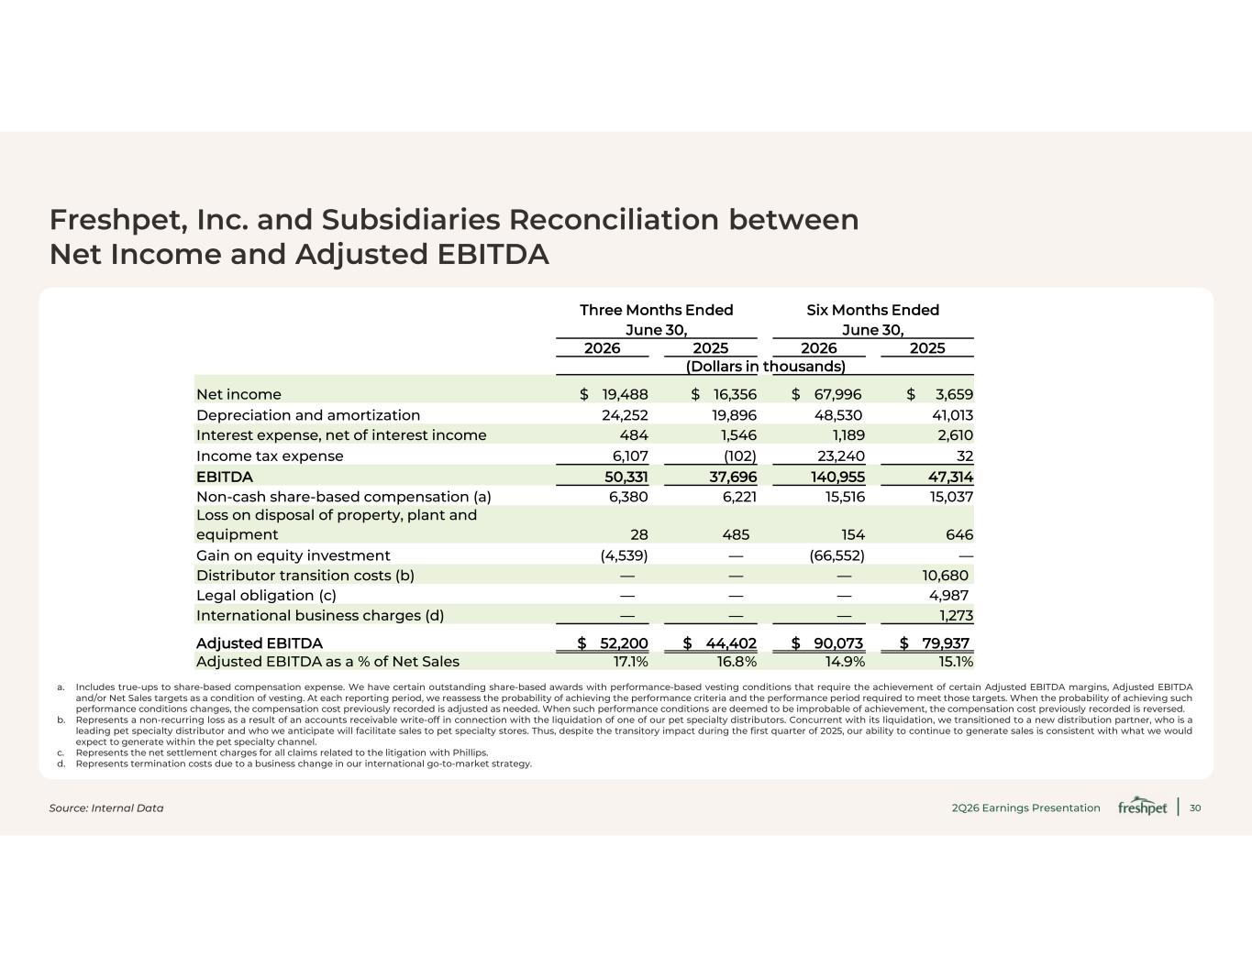
30 Freshpet, Inc. and Subsidiaries Reconciliation between Net Income and Adjusted EBITDA a. Includes true-ups to share-based compensation expense. We have certain outstanding share-based awards with performance-based vesting conditions that require the achievement of certain Adjusted EBITDA margins, Adjusted EBITDA and/or Net Sales targets as a condition of vesting. At each reporting period, we reassess the probability of achieving the performance criteria and the performance period required to meet those targets. When the probability of achieving such performance conditions changes, the compensation cost previously recorded is adjusted as needed. When such performance conditions are deemed to be improbable of achievement, the compensation cost previously recorded is reversed. b. Represents a non-recurring loss as a result of an accounts receivable write-off in connection with the liquidation of one of our pet specialty distributors. Concurrent with its liquidation, we transitioned to a new distribution partner, who is a leading pet specialty distributor and who we anticipate will facilitate sales to pet specialty stores. Thus, despite the transitory impact during the first quarter of 2025, our ability to continue to generate sales is consistent with what we would expect to generate within the pet specialty channel. c. Represents the net settlement charges for all claims related to the litigation with Phillips. d. Represents termination costs due to a business change in our international go-to-market strategy. Source: Internal Data 2Q26 Earnings Presentation Six Months Ended June 30, Three Months Ended June 30, 2025202620252026 (Dollars in thousands) $ 3,659$ 67,996$ 16,356$ 19,488Net income 41,01348,53019,89624,252Depreciation and amortization 2,6101,1891,546484Interest expense, net of interest income 3223,240(102)6,107Income tax expense 47,314140,95537,69650,331EBITDA 15,03715,5166,2216,380Non-cash share-based compensation (a) 64615448528 Loss on disposal of property, plant and equipment —(66,552)—(4,539)Gain on equity investment 10,680———Distributor transition costs (b) 4,987———Legal obligation (c) 1,273———International business charges (d) $ 79,937$ 90,073$ 44,402$ 52,200Adjusted EBITDA 15.1%14.9%16.8%17.1%Adjusted EBITDA as a % of Net Sales

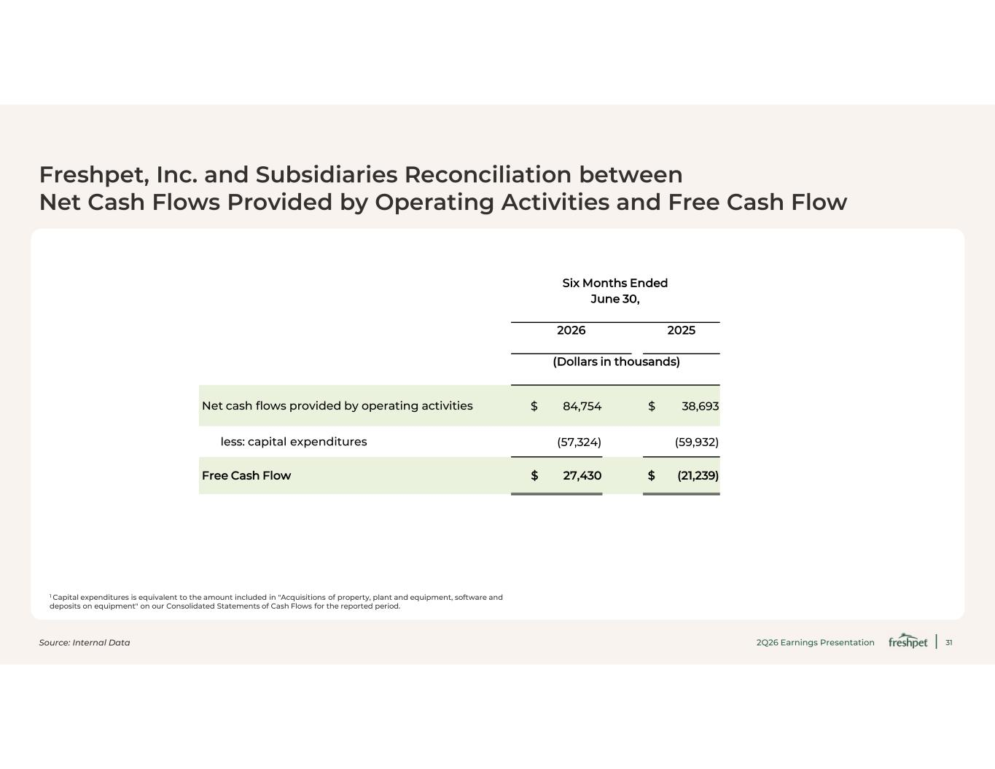
31 Freshpet, Inc. and Subsidiaries Reconciliation between Net Cash Flows Provided by Operating Activities and Free Cash Flow 1 Capital expenditures is equivalent to the amount included in "Acquisitions of property, plant and equipment, software and deposits on equipment" on our Consolidated Statements of Cash Flows for the reported period. Source: Internal Data 2Q26 Earnings Presentation Six Months Ended June 30, 20252026 (Dollars in thousands) $ 38,693$ 84,754Net cash flows provided by operating activities (59,932)(57,324)less: capital expenditures $ (21,239)$ 27,430Free Cash Flow

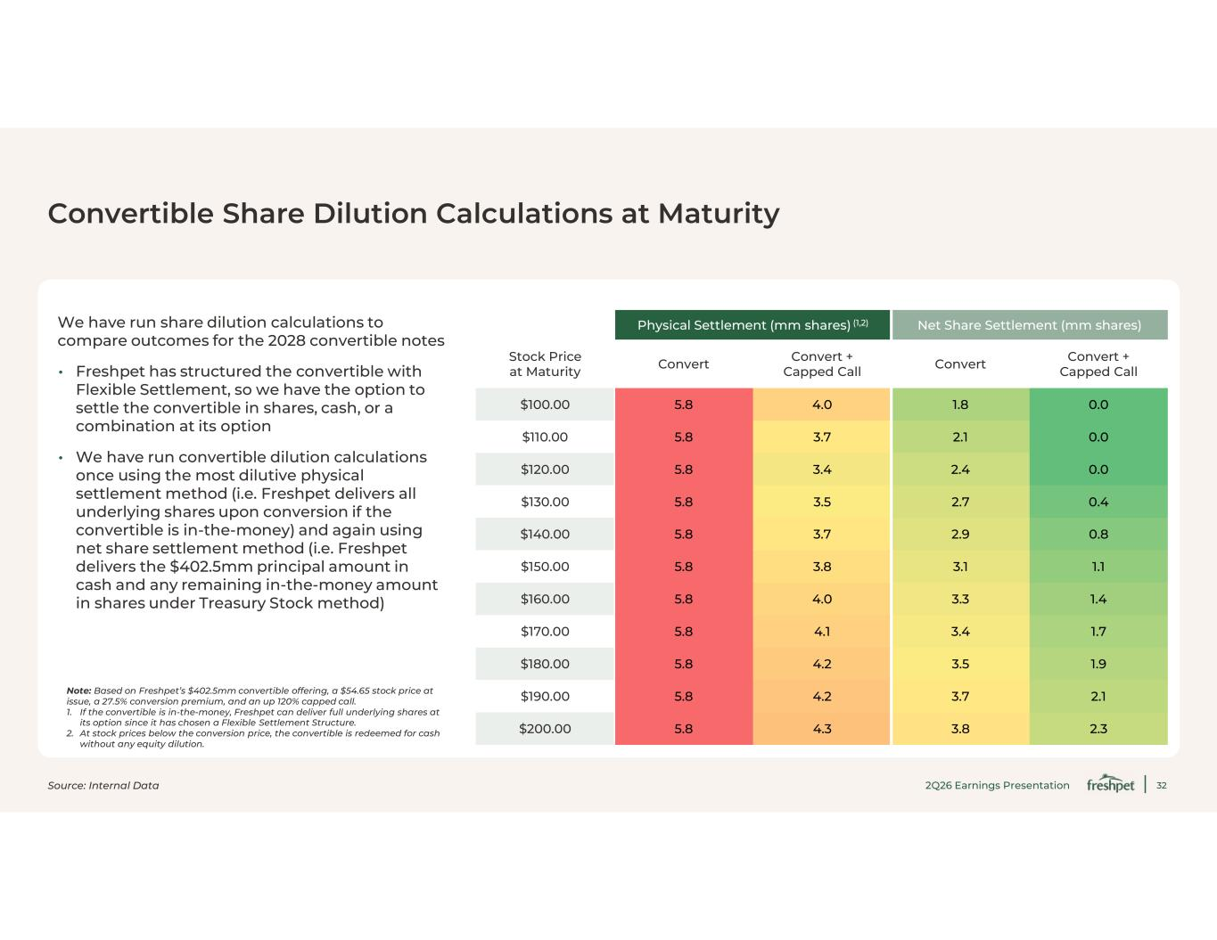
32 Convertible Share Dilution Calculations at Maturity We have run share dilution calculations to compare outcomes for the 2028 convertible notes • Freshpet has structured the convertible with Flexible Settlement, so we have the option to settle the convertible in shares, cash, or a combination at its option • We have run convertible dilution calculations once using the most dilutive physical settlement method (i.e. Freshpet delivers all underlying shares upon conversion if the convertible is in-the-money) and again using net share settlement method (i.e. Freshpet delivers the $402.5 mm principal amount in cash and any remaining in-the-money amount in shares under Treasury Stock method) Note: Based on Freshpet’s $402.5 mm convertible offering, a $54.65 stock price at issue, a 27.5% conversion premium, and an up 120% capped call. 1. If the convertible is in-the-money, Freshpet can deliver full underlying shares at its option since it has chosen a Flexible Settlement Structure. 2. At stock prices below the conversion price, the convertible is redeemed for cash without any equity dilution. Net Share Settlement (mm shares)Physical Settlement (mm shares) (1,2) Convert + Capped CallConvertConvert + Capped CallConvertStock Price at Maturity 0.01.84.05.8$100.00 0.02.13.75.8$110.00 0.02.43.45.8$120.00 0.42.73.55.8$130.00 0.82.93.75.8$140.00 1.13.13.85.8$150.00 1.43.34.05.8$160.00 1.73.44.15.8$170.00 1.93.54.25.8$180.00 2.13.74.25.8$190.00 2.33.84.35.8$200.00 Source: Internal Data 2Q26 Earnings Presentation


33 Thank you

